|  |  |
| --- | --- |
|  | **FPT ACADEMY INTERNATIONAL**  **FPT - APTECH COMPUTER EDUCATION** |

***RESORT MANAGEMENT***

|  |  |  |  |
| --- | --- | --- | --- |
| **Center Name** | | ACE-HCMC-2-FPT  Address: 590 Cach Mang Thang Tam, District 3, HCMC, Vietnam. | |
| **Instructor** | | Mr. Tran Phuoc Sinh | |
| **Class** | | T1.1809.A0 | |
| **Group** | | 02 | |
| **Group members** | | **Name** | **Student ID** |
| Trinh Thiem Bao | Student1141125 |
| Ly Thi Thuy Tien | Student1140017 |
| Nguyen Quoc Thai | Student1140019 |
| **Duration** | **Start date** | July 08th 2020 | |
| **End date** | August 10th 2020 | |

This is to certify that

Mr. Trinh Thiem Bao

Ms. Ly Thi Thuy Tien

Mr. Nguyen Quoc Thai



have successfully designed and

developed 

Submitted by:

Date of Issue: July 08th 2020 07________

Authorized Signature: ___________

**Mr. Tran Phuoc Sinh**Mr. Tran Phuoc Sinh


**Table of Contents**

REVIEW 1 4

I. ACKNOWLEDGEMENT 5

II. PROBLEM DEFINITION 6

III. REQUIREMENT SPECIFICATION 6

IV. System REQUIREMENT SPECIFICATIONS 7

1. Server requirements 7

2. Client requirements: 7

REVIEW 2 9

I. ARCHITECTURE & DESIGN OF THE PROJECT 10

1. Web Tier 10

2. Enterprise Tier 11

II. USE CASE DIAGRAMS 11

3. Admin use case 11

4. Employee use case 12

5. User use case 13

III. SEQUENCE DIAGRAMS 14

1. User (guest) 14

2. Admin sequence diagrams 27

3. Employee sequence diagrams 51

IV. DATABASE DESIGN 53

1. Logical design (Entity Relationship Diagram) 53

REVIEW 3 56

I.Database design 57

1.Database Design Diagram 57

2.Database STructure 57

II. Gui DESIGN 63

1.User Interface 63

2.Customer Interface 70

3.Admin Interface 76

4.Employee Interface 85

**REVIEW 1**

## ACKNOWLEDGEMENT

We would like to acknowledge all those who have given support and help us make the project a success .

We wish to express our deep gratitude to all teachers who have been devoting their lives to teach us how to stand-alone and walk ahead .

We are grateful to our families who take care and encourage us even though we are successful or failed, also to our friends who are always care of us. They never leave us alone and always look forward to us when we are on any road of the life .

We are much thankful to the entire staff and chairpersons at the Head Office of Aptech Worldwide, Aptech – Vietnam, and FPT – Aptech Center who have been organizing and looking after our studying course .

There are no words to show our appreciation for teachers of FPT Aptech Centre who have been organizing and looking after us during our studying course to finish this project. Our special thanks Mr Tran Phuoc Sinh who works day by day to teach and guide us, e-Project Team at the Head Office who instruct and help us .

Finally, we would like to offer many thanks to all our schoolfellows for their valuable suggestions .

We would like to thank sincerely !

## PROBLEM DEFINITION :

1. **Introduction :**
2. Haven Deluxe is an application site where users can choose to book rooms and resort services online. After authentication, we will send users a QRCode to check in at the resort .
3. Haven Deluxe is the perfect choice for consumers who don't have time to book and the services needed to enjoy the holiday.

## REQUIREMENT SPECIFICATION :

1. **WEBSITE:**
2. The website must contain all rooms in the resort and entertainment services..
3. The homepage must be well designed and formatted with all navigation links, appropriate headers and footers of the site, Links to login in the site.
4. It should contain links such as Booking, Services ,Location , About Us, Cart, sign in and Sign up for new customers.
5. **ADMIN:**
6. Administrators can delete all Item (no longer active)
7. Administrators can create accounts (including employee and customer accounts), change any account status to active or inactive (except for Administrator accounts that can only be edited ).
8. Administrators can create, update and delete information in the pages About Us, Service, Location and Rooms.
9. Administrators are the only ones who can delete feedback from users.
10. Administrators can delete orders, change order status.
11. **EMPLOYEE:**
12. Employee is checking customer information .
13. Employees can activate QRCode of customers .
14. The employee can read the order and change the status of the order after verification (verification, payment) .
15. **USER (not logged in):**
16. Users can view rooms, entertainment services.
17. Users can send feedback to the store.
18. Users can register for a new account.
19. **USER (logged in):** 
    * 1. The user can do anything like a User that is not logged in .
      2. Users of their payment history.
      3. Users can add, edit and delete accessories from the cart.
20. **Note:** Constraint validation must be provided wherever necessary. And the website should have the smooth navigations.

## System REQUIREMENT SPECIFICATIONS

### Server requirements

* Hardware:

|  |  |
| --- | --- |
| Component | Requirement |
| CPU | Processor type:  Pentium IV-compatible processor or faster  Processor speed:  Recommended: 2.0 GHz or faster |
| OS | Microsoft Windows XP or higher with IIS |
| Memory (RAM) | RAM: Minimum: 512 MB  Recommended: 2 GB or more |
| Hard Drive | Free space:  Minimum: 200 MB  Recommended: 50 GB or more  Maximum: Operating system maximum |

* Software:

|  |  |
| --- | --- |
| Component | Requirement |
| Microsoft .NET Framework | Version 4.5.1 |
| RDBMS | Microsoft SQL Server 2012 |

### Client requirements:

* Hardware:

|  |  |
| --- | --- |
| Component | Requirement |
| CPU | Processor type:  Pentium III-compatible processor or faster  Processor speed:  Recommended: 1.0 GHz or faster |
| OS | All OS (Window, Linux, Android, Mac OS …) |
| Memory (RAM) | RAM: Minimum: 512 MB  Recommended: 1 GB or more  Maximum: Operating system maximum |
| Hard Drive | Free space: Minimum: 10 MB |

* Software:

|  |  |
| --- | --- |
| Component | Requirement |
| Web Browser | IE 4.0, Firefox 3.0, Chrome or Higher…. |

**3.** T**echnology:** JPA, JSP-Servlet,Resful Service.

TASK SHEET REVIEW 1

|  |  |  |  |  |  |  |  |  |
| --- | --- | --- | --- | --- | --- | --- | --- | --- |
| Project Ref. No.: | | Project Title: | Activity Plan Prepared By: | Date of Preparation of Activity Plan: | | | | |
| No. | Task | Actual Start Date | Actual Days | Teammate Names | Status |
| 1 | Acknowledgement | Resort Management | Nguyen Quoc Thai | 08/07/2020 | 1 | All member | Completed |
| 2 | Problem Definition | 08/07/2020 | 1 | All member | Completed |
| 3 | Requirement Specification | 08/07/2020 | 1 | All member | Completed |
| 4 | Task sheet review | 08/07/2020 | 1 | All member | Completed |

|  |  |
| --- | --- |
| **Date: 08/07/2020** | |
| Signature of Instructor:  **Mr. Tran Phuoc Sinh** | Signature of Team Leader:  **Trinh Thiem Bao** |

**REVIEW 2**

## ARCHITECTURE & DESIGN OF THE PROJECT

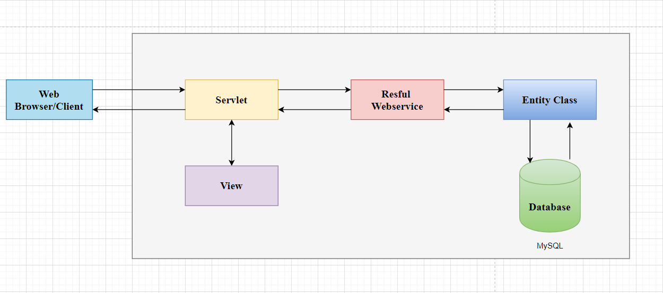

1. **Web Tier :**

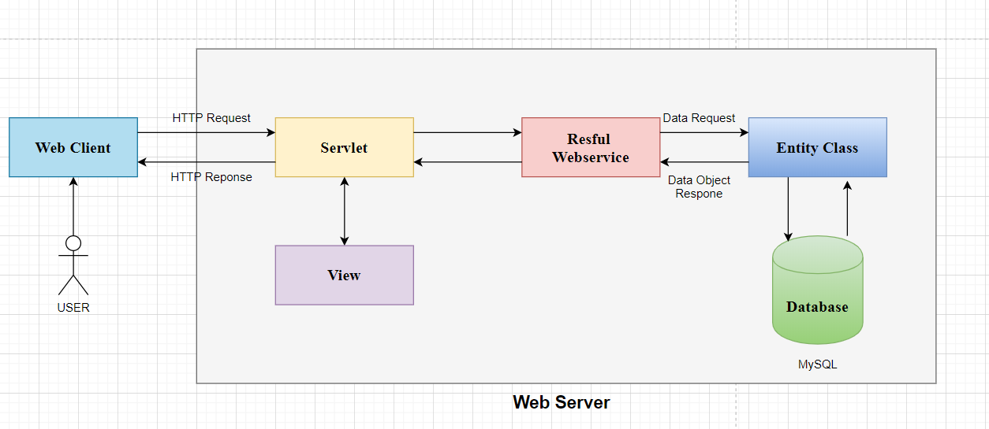

* + Technology: JSP- Servlet
  + Model- This level is responsible for all kinds of business logic operations. It has the classes which have the connection with the database .
  + View- This is the presentation layer which consists of HTML, JSP pages. This layer is responsible for displaying the application’s output to the end users.
  + Controller- This layer handles the HTTP requests and sends to the appropriate . Model layer for data processing, and once the data are processed and sent back to the controller and then displayed on the View layer .

### Enterprise Tier :

* Techology: Resful Webservice, JPA .
* RESTful Web Services are Web Services written based on the REST architecture. REST has been widely used as an alternative to SOAP and WSDL-based Web Services. RESTful Web Service is lightweight (lightweigh), easy to extend and maintain .
* Java Persistence API (JPA) is a source to store business entities as relational entities. It shows how to define a PLAIN OLD JAVA OBJECT (POJO) as an entity and how to manage entities with relations .

## USE CASE DIAGRAMS :

### Admin use case :

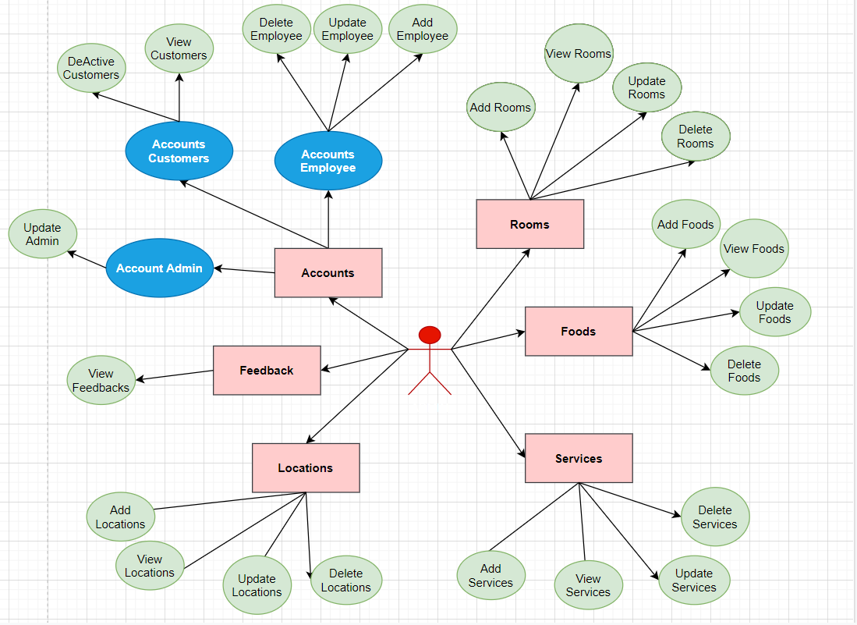

### Employee use case :

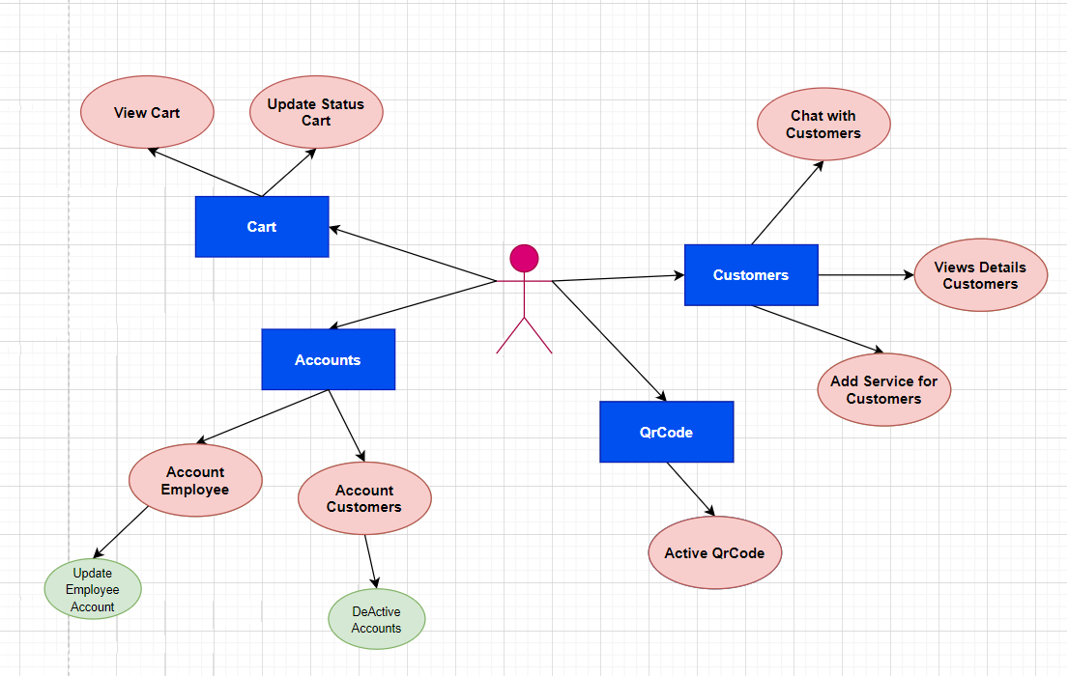

### User use case :

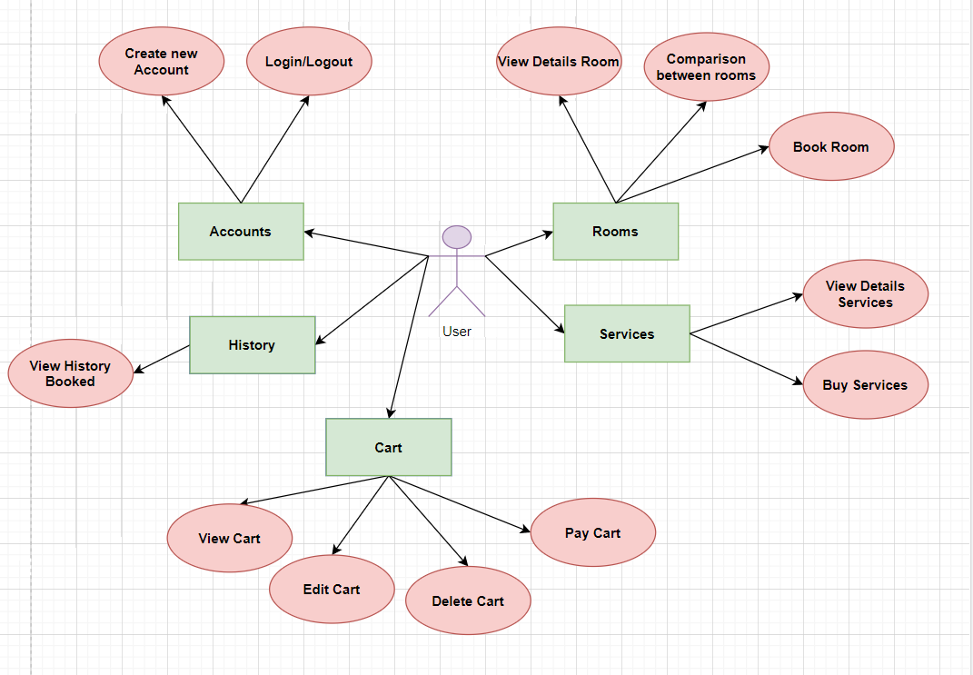

## SEQUENCE DIAGRAMS

### User (guest) :

#### **Sign Up :**

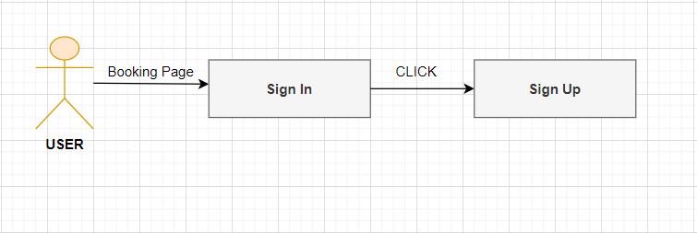

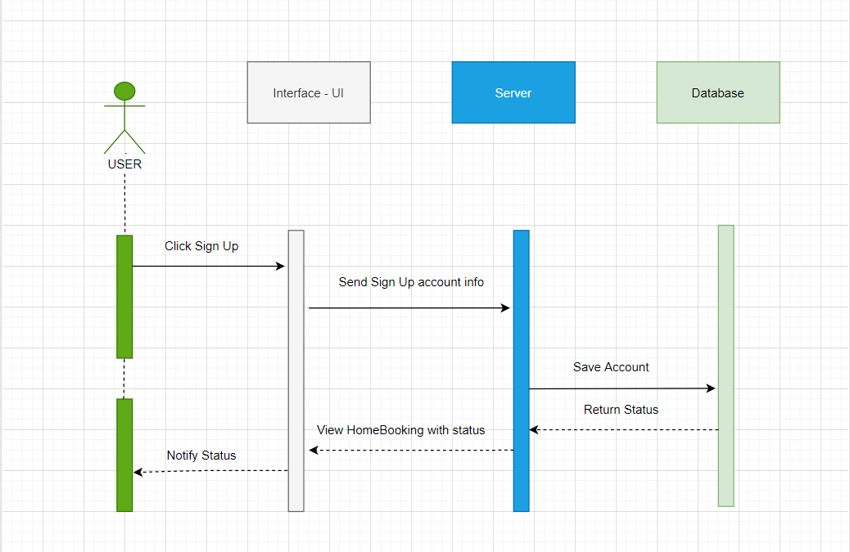

|  |  |  |
| --- | --- | --- |
| **Author** |  | |
| **Use Case Name** | Sign Up | |
| **Actors** | User | |
| **Description** | Register account for login website to booking | |
| **Requirements** | User must provide personal’s information | |
| **Pre-Conditions** |  | |
| **Post-Conditions** | Success: The user account will be created Failed: Refill information | |
| **Basic flow** | Actor action:  1. Actor clicks “Sign Up” link in home page  3. Actor provides registration’s information  4.Actor click “Register ” button. | System Response:  2. System redirects to Registration company page with following control:  • “Email” text field  • “Password” text field  • “UserName” text field  • “Phone” text field  5. System validates information  6. System inserts data into database and sends message “Your information has been created.” |
| **Alternative flow** | Actor action: 1. Actor clicks other link | System responses:  2. System redirects to other page. |
| **Exception** | Actor action:   * “Email” cannot be blank * “Email” is invalid * “Password” cannot be blank * “Password” is invalid * “Name cannot be blank * “Name” is invalid * “Phone” cannot be blank “Phone” is invalid | System Response:  • “Email” cannot be blank  • “Email” has already exist  • “Email” invalid  • “Password” cannot be blank  • “Password” invalid  • “Name” cannot be blank  • “Name” invalid  • “Phone” cannot be blank • “Phone” invalid |

#### **Sign In :**

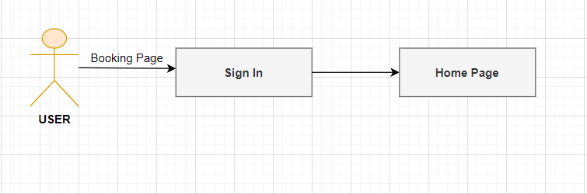

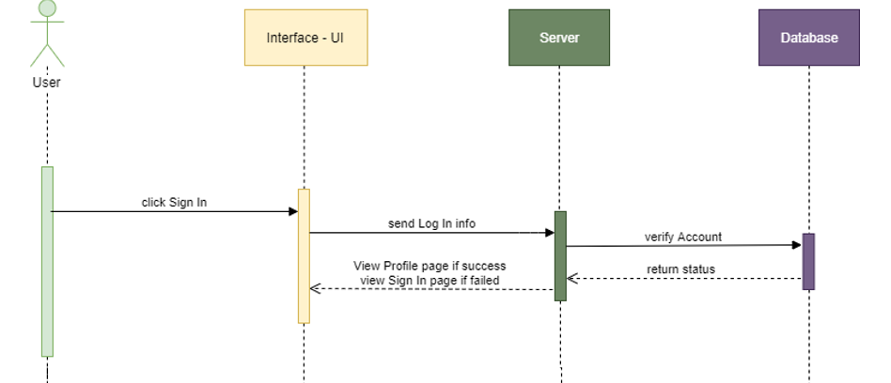

|  |  |  |
| --- | --- | --- |
| **Author** |  | |
| **Use Case Name** | Log in | |
| **Actors** | User | |
| **Description** | User want to login to system to manage his/her account ,view information ,booking room | |
| **Requirements** | Guest must provide Email and Password | |
| **Pre-Conditions** |  | |
| **Post-Conditions** | Success: Login success Failed:  Refill information and try to login again | |
| **Basic flow** | Actor action:  1. Actor clicks “Login” link in home page  3. Actor provides Email and Password  4. Actor enters Email and Password, the click on the “Login” button | System Response:   1. System redirects to Login page with following control:   • “Email” textfield  • “Password” textfield  5. System validates information  6. System check the customer username and password in database. If correct page will redirect to Home page. Otherwise, the message is “Log in fail” |
| **Alternative flow** | Actor action:  1. Actor clicks other link | System responses:  2. System redirects to other page. |
| **Exception** | Actor action:  • “Email” cannot be blank  • “Password” cannot be blank | System Response:  • “Email” cannot be blank  • “Email” invalid  • “Password” cannot be blank  • “Password” invalid |

#### **Homepage :**

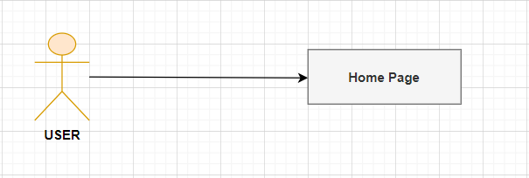

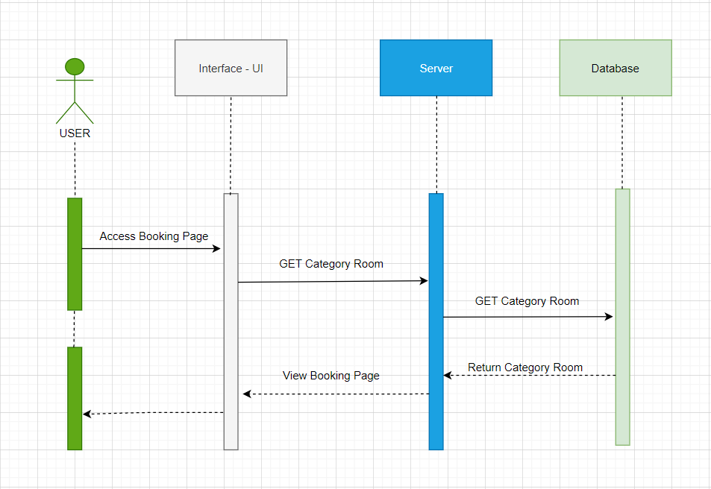

1. **View Room :**

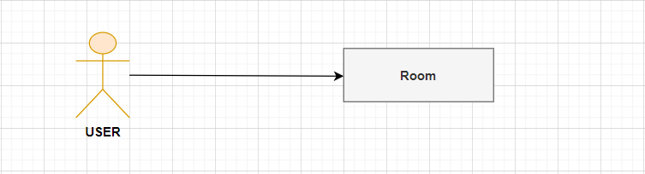

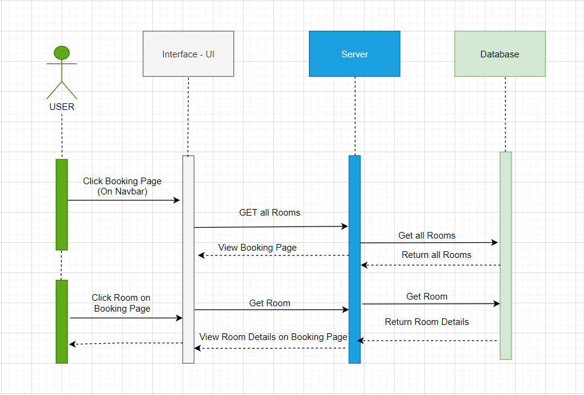

|  |  |  |
| --- | --- | --- |
| **Author** |  | |
| **Use Case Name** | View Room Details | |
| **Actors** | User | |
| **Description** | User wants to view all information about a specific product. | |
| **Requirements** | User clicks Room under the thumbnail image of the product. | |
| **Pre-Conditions** |  | |
| **Post-Conditions** | Success: Display product details page. | |
| **Basic flow** | Actor action:  1. Actor clicks Room Name under the thumbnail image of the product. | Systems display Room Details page with following controls:  You can see all information of the room. Include:   * Price, * Number of people, * Number of beds, * View, * And price |
| **Alternative flow** | Actor action:  1. Actor clicks other link | System responses:  2. System redirects to other page. |
| **Exception** |  |  |

#### **Feedbacks :**

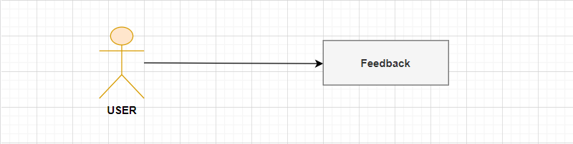

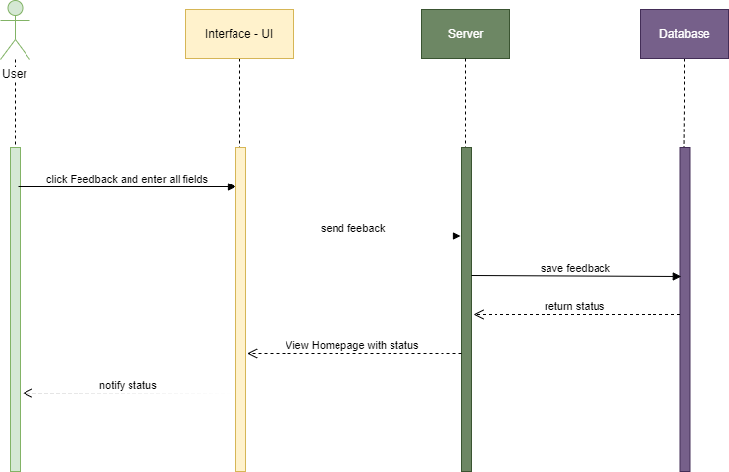

|  |  |  |
| --- | --- | --- |
| **Author** |  | |
| **Use Case Name** | Feedbacks | |
| **Actors** | User | |
| **Description** | User wants write feedback about the room | |
| **Requirements** | User type comment in feedback area under the product details. | |
| **Pre-Conditions** | User logged in & being at Room Details page. | |
| **Post-Conditions** | Success: comment will send for management page when user click submit | |
| **Basic flow** | Actor Actions:   1. User type comment in the comment area under Room details. 2. Then click   Submit button . | System Responses:  3. System inserts comment to database. |
| **Alternative flow** | Actor action:  1. Actor clicks other link | System responses:  2. System redirects to other page. |
| **Exception** | Actor Action :   * Feedback Message cant not blank | System Response:  • “FeedbackMessage” cannot be blank  • “FeedbackMessage” invalid |

#### **Cart :**

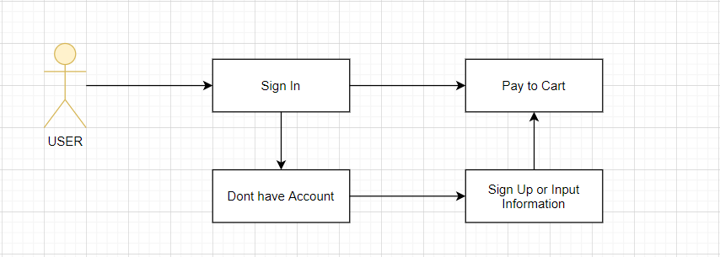

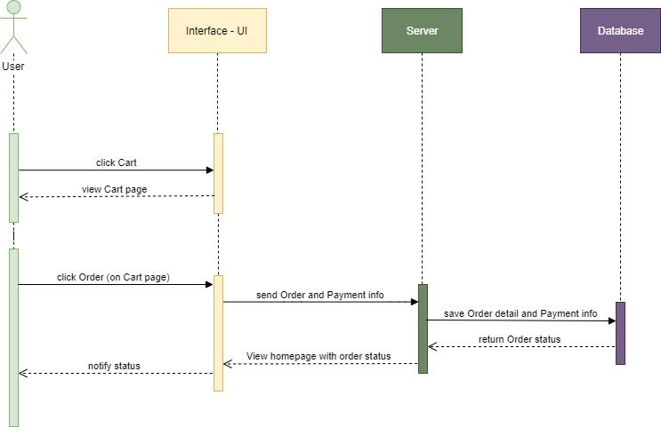

|  |  |  |
| --- | --- | --- |
| **Author** |  | |
| **Use Case Name** | Booking Page | |
| **Actors** | User | |
| **Description** | User wants to put Room into Booking cart or create new order. | |
| **Requirements** | User clicks Add To Cart button under Room image. | |
| **Pre-Conditions** |  | |
| **Post-Conditions** | Success: Room name and purchase quantity appear in the shopping cart. | |
| **Basic flow** | 1. Actor clicks Add To Cart button under Room image. | 2. Room name into the shopping cart & display shopping cart page.  User changes purchase quantity in shopping cart page comment to database. |
| **Alternative flow** |  |  |
| **Exception** |  |  |

#### **History :**

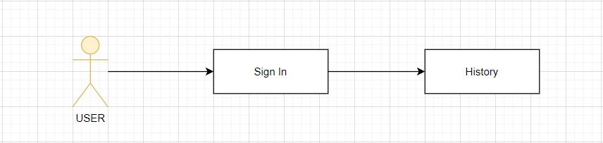

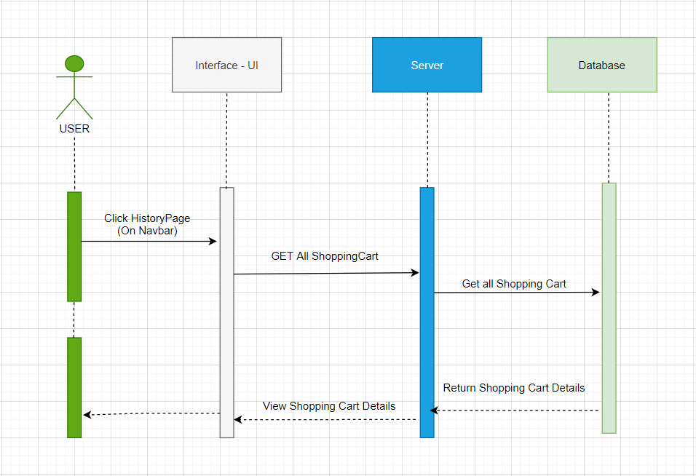

|  |  |  |
| --- | --- | --- |
| **Author** |  | |
| **Use Case Name** | History Page | |
| **Actors** | User | |
| **Description** | User can see their reservation history and the services they have booked | |
| **Requirements** | User Login Success | |
| **Pre-Conditions** |  | |
| **Post-Conditions** | Success: Sign in successfully and have paid rooms and services . | |
| **Basic flow** | 1. User clicks History in navbar. | 1. Users can view payment history:  * Room name, * Checkin date - checkout, * Services * Quantity * Price. |
| **Alternative flow** |  |  |
| **Exception** |  |  |

#### **Admin sequence diagrams :**

#### **Login :**

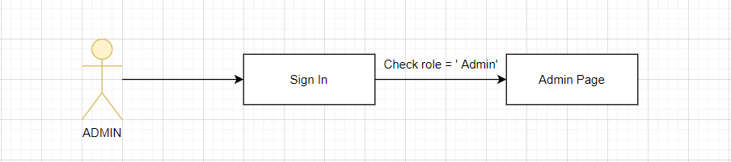

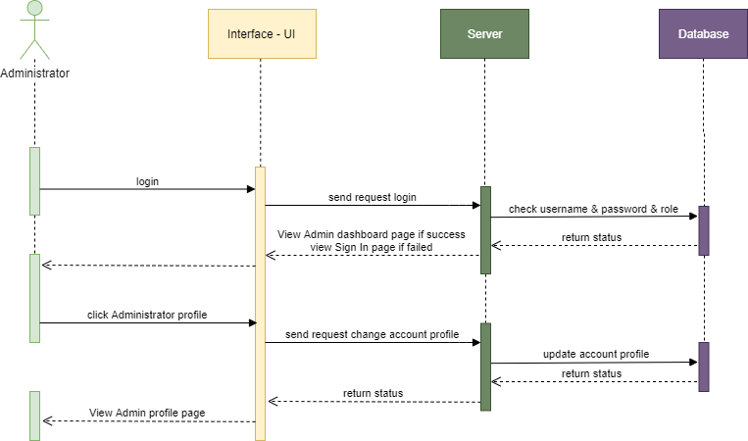

|  |  |  |
| --- | --- | --- |
| **Author** |  | |
| **Use Case Name** | Log in | |
| **Actors** | Admin | |
| **Description** | Admin want to login to system to manage his/her account ,view information customer and employee, services ,convenients ,locations ,receipt , and room | |
| **Requirements** | Guest must provide Email, Password and role = “Admin” | |
| **Pre-Conditions** |  | |
| **Post-Conditions** | Success: Login success Failed:  Refill information and try to login again | |
| **Basic flow** | Actor action:  1. Actor clicks “Login” link in Admin page  3. Actor provides Email and Password  4. Actor enters Email and Password, the click on the “Login” button | System Response:   1. System redirects to Login page with following control:   • “Email” textfield  • “Password” textfield  5. System validates information  6. System check the admin email ,password and role = “Admin” in database. If correct page will redirect to Admin page. Otherwise, the message is “Log in fail” |
| **Alternative flow** | Actor action:  1. Admin clicks Login page | System responses:  2. System redirects to Admin page. |
| **Exception** | Actor action:  • “Email” cannot be blank  • “Password” cannot be blank | System Response:  • “Email” cannot be blank  • “Email” invalid  • “Password” cannot be blank  • “Password” invalid |

#### **Employees :**

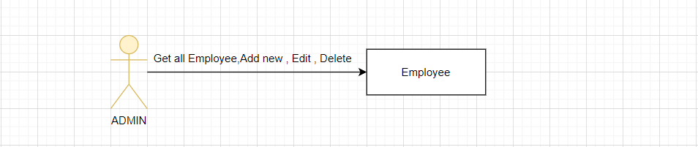

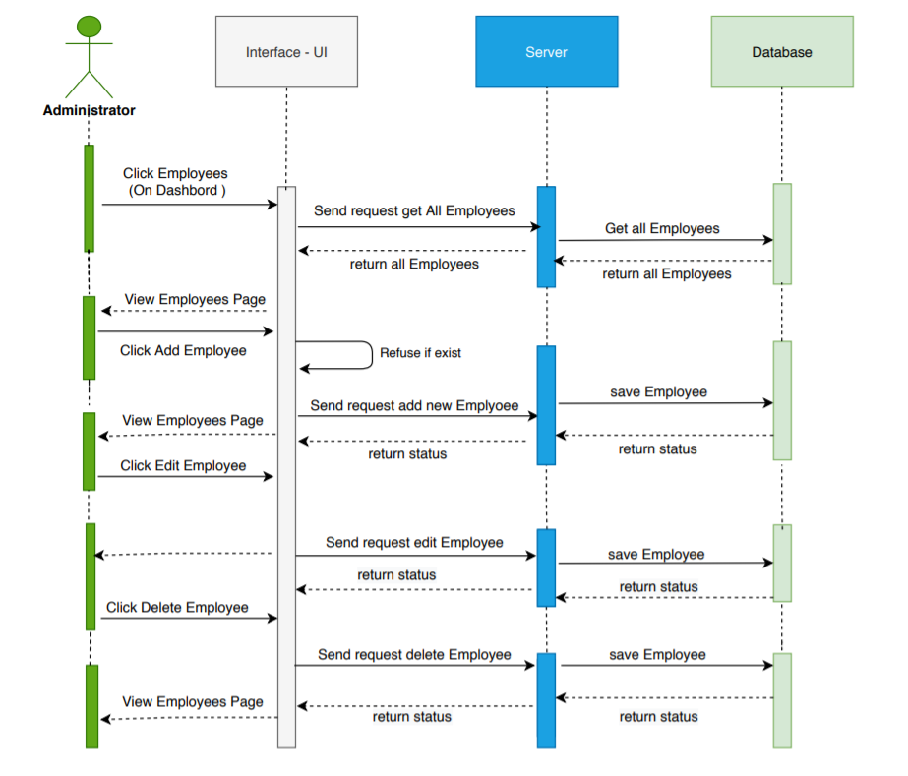

* **View Employee List :**

|  |  |  |
| --- | --- | --- |
| **Use Case Name** | View profile Employee | |
| **Actors** | Admin | |
| **Description** | Admin wants to view profile information. | |
| **Requirements** | Admin clicks ‘Employee’ link. | |
| **Pre-conditions** | Logged in. | |
| **Post-conditions** | Success: Employee page is opened. | |
| **Basic flow** | **Actor Actions** | **System Responses** |
|  | 1.   * Administrator: move the cursor to Employees and click on the Employee List link. | 2. System opens Employee List page with the information of the current account:   * Emplyoee Infor   + Full Name textfield   + Email textfield   + DOB textfield   + Phone textfield   + Update button   + Delete button |
| **Alternative flow** |  |  |
| **Exception** |  |  |

* **Add new Employee :**

|  |  |  |
| --- | --- | --- |
| **Use Case Name** | Admin can add new Employee | |
| **Actors** | Admin | |
| **Description** | Add new Employee | |
| **Requirements** | Actor has already logged into the System as Administrator | |
| **Pre-conditions** |  | |
| **Post-conditions** | Success: Display new Employee  Failed: Refill information. | |
| **Basic flow** | **Actor Actions** | **System Responses** |
|  | * Actor action: 1. At Employee List, Actor click Add new Employee * 3. Actor: - Inputs into ‘Email’ textfield.   - Inputs into ‘FullName’ textfield.  - Inputs into ‘Phone’ textfield.  - Inputs into ‘Password’ textfield.  Clicks on to ‘Create button to finish adding. | System Responses:  2. System redirects to ‘add New Employee ‘ page and display form with the following controls:  - ‘Email’ textfield.  - ‘FullName’ textfield.  - ‘Password’ textfield.  - ‘Phone’ textfield.  4.System add new Employee and insert into the database with status default =0 (closing). redirects to ‘view Employee’ page. 5. System insert into the database |
| **Alternative flow** |  |  |
| **Exception** | [Exception 1] – All TextField is not empty | System displays a message to notice actor:  - “All textfield is not blank” |

* **Update Employee :**

|  |  |  |
| --- | --- | --- |
| **Use Case Name** | Update profile Emplyoee | |
| **Actors** | Admin | |
| **Description** | Admin wants to change Employee profile information. | |
| **Requirements** | Admin changes current information and clicks Save changes. | |
| **Pre-conditions** |  | |
| **Post-conditions** | Success: Return to Employee List page. | |
| **Basic flow** | Admin Actions:  1. To change account details, actor changes information in the form below:   * Employee Information form   + Email textfield * DOB textfield * Phone textfield * Update button * Delete button   Clicks Save Update | System Responses:  2. Systems updates new information to database, show ‘Profile is updated’ message and returns to Profile Account page. |

#### **Customers :**

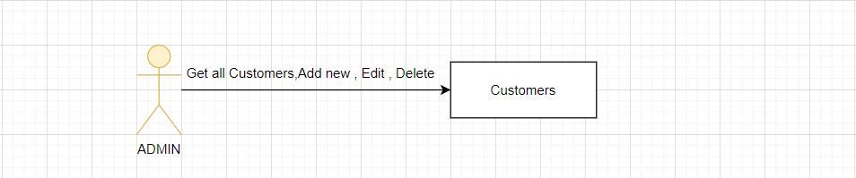

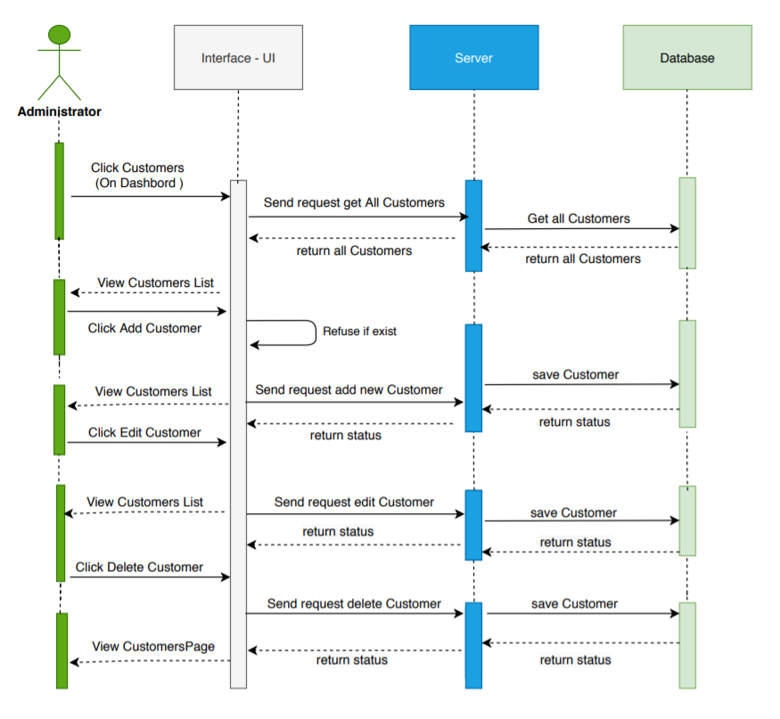

* **View Customer :**

|  |  |  |
| --- | --- | --- |
| **Use Case Name** | View profile Customer | |
| **Actors** | Admin | |
| **Description** | Admin wants to view profile information. | |
| **Requirements** | Admin clicks ‘Customer’ link in navbar. | |
| **Pre-conditions** | Logged in with role Admin. | |
| **Post-conditions** | Success: Customer page is opened. | |
| **Basic flow** | **Actor Actions** | **System Responses** |
|  | 1.   * Administrator: move the cursor to Customer and click on the Customer List link in navbar. | 2. System opens Employee List page with the information of the current account:   * Customer Infor :   + Full Name textfield   + Email textfield   + Phone textfield   + Active textfield   + Update button   + Delete button |
| **Alternative flow** |  |  |
| **Exception** |  |  |

* **Update Customer :**

|  |  |  |
| --- | --- | --- |
| **Use Case Name** | Update profile Customer | |
| **Actors** | Admin | |
| **Description** | Admin wants to change Customer profile . | |
| **Requirements** | Admin changes current information and clicks Save changes. | |
| **Pre-conditions** |  | |
| **Post-conditions** | Success: Return to Employee List page. | |
| **Basic flow** | Admin Actions:  1. To change account details, actor changes information in the form below:   * Employee Information form   + Email textfield * Active textfield * Phone textfield * Update button * Delete button   Clicks Save Update | System Responses:  2. Systems updates new information to database, show ‘Profile is updated’ message and returns to Profile Account page. |

#### **Rooms :**

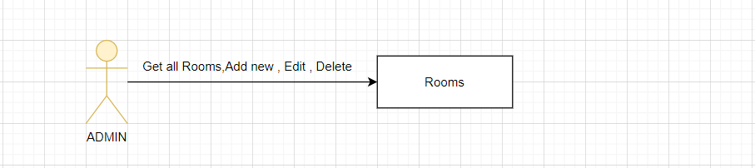

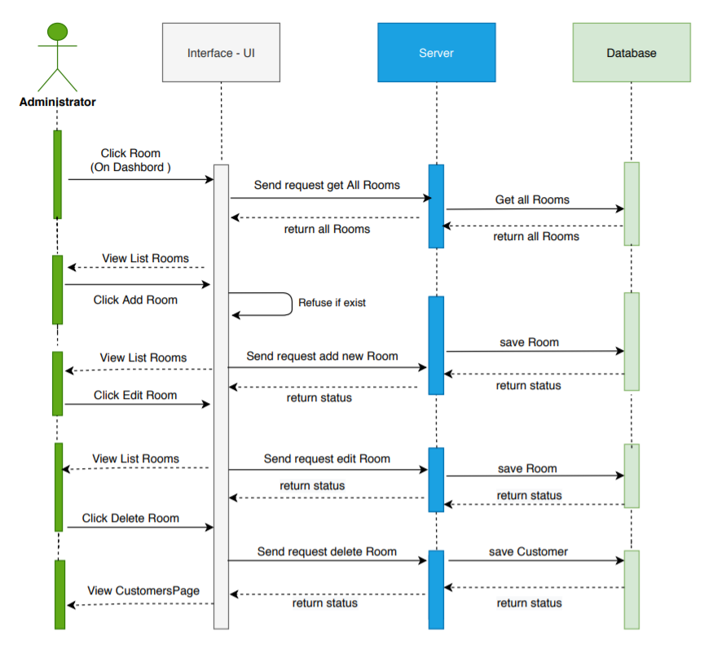

#### **Location :**

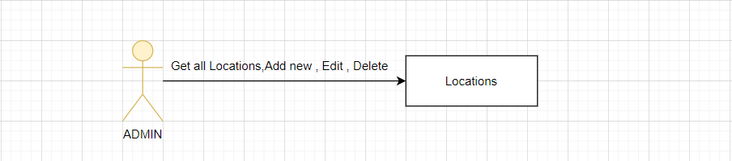

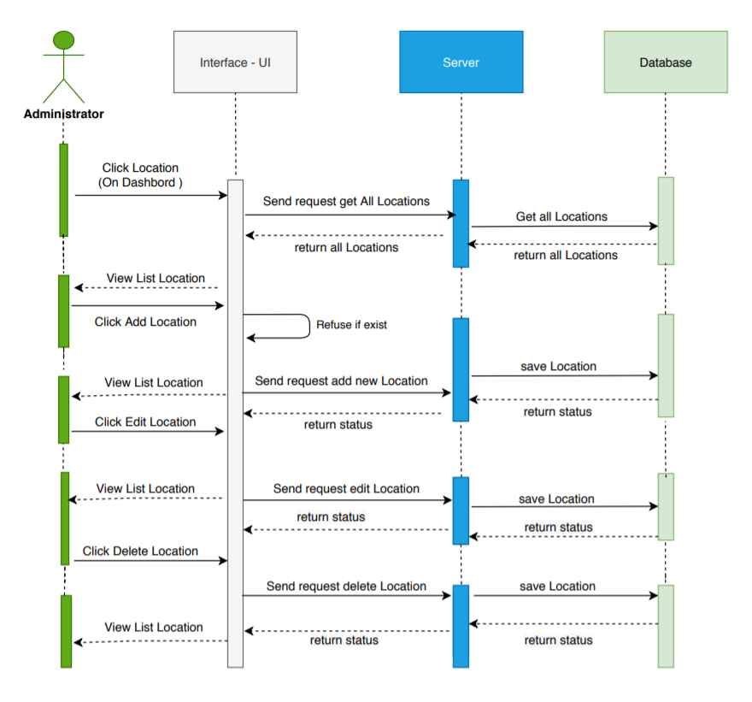

* **View Location :**

|  |  |  |
| --- | --- | --- |
| **Use Case Name** | View Location List | |
| **Actors** | Admin | |
| **Description** | Admin wants to view Location List. | |
| **Requirements** | Admin clicks ‘Location in navbar. | |
| **Pre-conditions** | Logged in with role Admin. | |
| **Post-conditions** | Success: Location page is opened. | |
| **Basic flow** | **Actor Actions** | **System Responses** |
|  | 1.   * Administrator: move the cursor to Location and click on the Location link in navbar. | 2. System opens Location List page with the information of the current account:   * Location List :   + Location Name   + Location Url   + Introduce   + Address   + Update button   + Delete button |
| **Alternative flow** |  |  |
| **Exception** |  |  |

* **Update Location** :

|  |  |  |
| --- | --- | --- |
| **Use Case Name** | Update Location | |
| **Actors** | Admin | |
| **Description** | Admin wants to change Location profile . | |
| **Requirements** | Admin changes current information and clicks Save changes. | |
| **Pre-conditions** |  | |
| **Post-conditions** | Success: Return to Location List page. | |
| **Basic flow** | Admin Actions:  1. To change Location details, actor changes information in the form below:   * Employee Information form   + Email textfield * Active textfield * Phone textfield * Update button * Delete button   Clicks Save Update | System Responses:  2. Systems updates new information to database, show ‘Profile is updated’ message and returns to Profile Location page. |

#### **Convenient :**

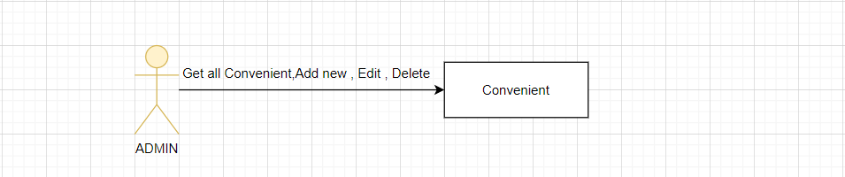

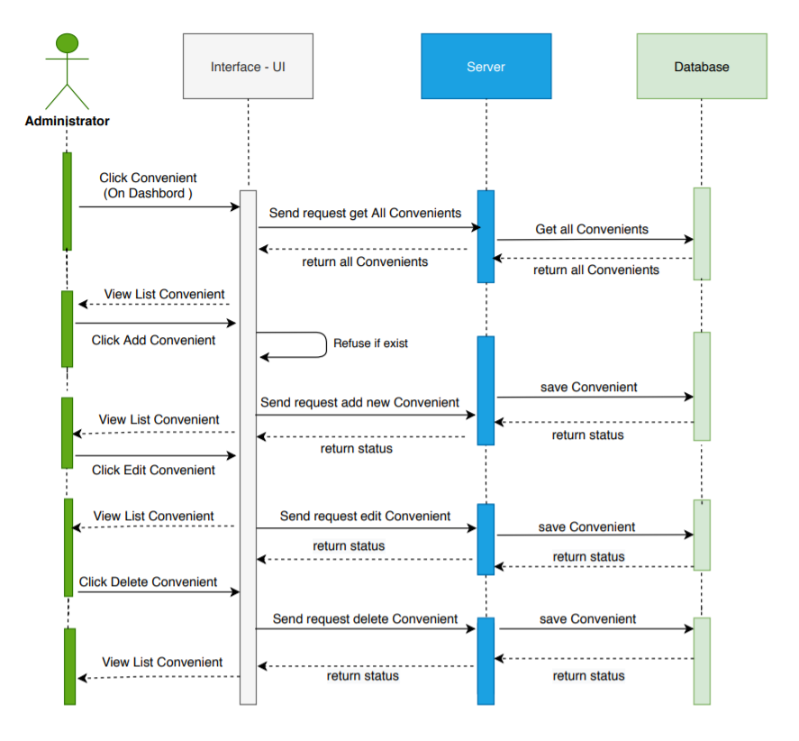

* **View Convenient :**

|  |  |  |
| --- | --- | --- |
| **Use Case Name** | View Convenient List | |
| **Actors** | Admin | |
| **Description** | Admin wants to view Convenient List. | |
| **Requirements** | Admin clicks ‘Convenient in navbar. | |
| **Pre-conditions** | Logged in with role Admin. | |
| **Post-conditions** | Success: Location page is opened. | |
| **Basic flow** | **Actor Actions** | **System Responses** |
|  | 1.   * Administrator: move the cursor to Location and click on the Location link in navbar. | 2. System opens Employee List page with the information of the current account:   * Location List :   + Convenient Name   + Covenient Url   + Update button   + Delete button |
| **Alternative flow** |  |  |
| **Exception** |  |  |

* **Update Convenient :**

|  |  |  |
| --- | --- | --- |
| **Use Case Name** | Update Covenient | |
| **Actors** | Admin | |
| **Description** | Admin wants to change Covenient profile . | |
| **Requirements** | Admin changes current information and clicks Save changes. | |
| **Pre-conditions** |  | |
| **Post-conditions** | Success: Return to Convenient List page. | |
| **Basic flow** | Admin Actions:  1. To change Convenient details, actor changes information in the form below:   * Convenient Update form :   + Convenient name textfield * Convenient url textfield * Update button   Clicks Save Update | System Responses:  2. Systems updates new information to database, show ‘Profile is updated’ message and returns to Covenient page. |

#### **Entertainments :**

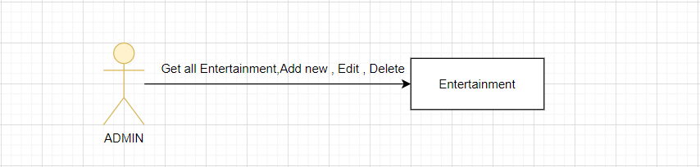

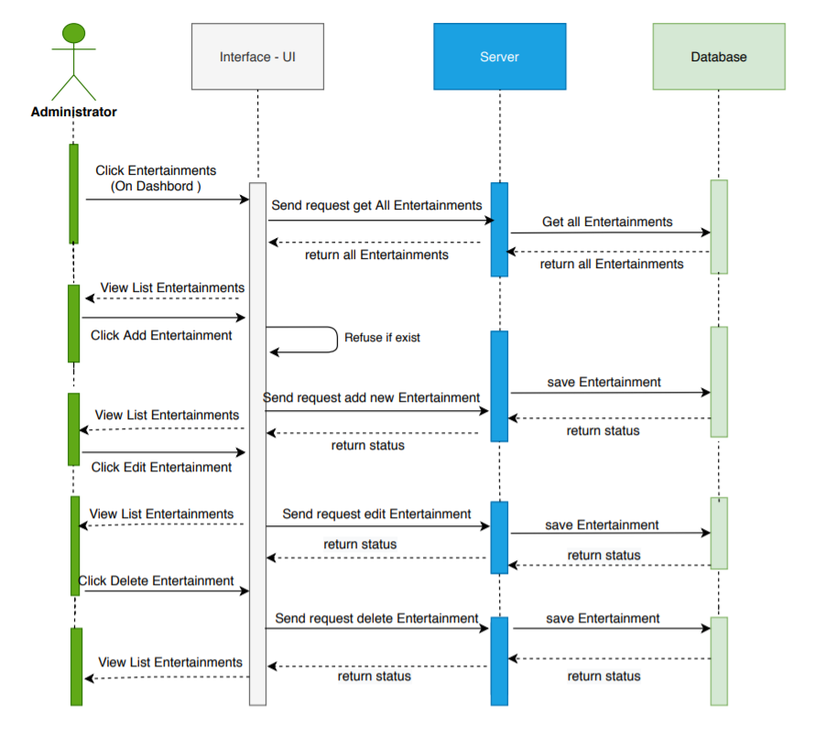

* **View Service :**

|  |  |  |
| --- | --- | --- |
| **Use Case Name** | View Service List | |
| **Actors** | Admin | |
| **Description** | Admin wants to view Service List. | |
| **Requirements** | Admin clicks ‘Service in navbar. | |
| **Pre-conditions** | Logged in with role Admin. | |
| **Post-conditions** | Success: Service page is opened. | |
| **Basic flow** | **Actor Actions** | **System Responses** |
|  | 1.   * Administrator: move the cursor to Location and click on the Service link in navbar. | 2. System opens Service List page with the information of the current account:   * Service List :   + Service Name   + Service Type   + Service Price   + Service Description   + Service Url   + Update button   + Delete button |
| **Alternative flow** |  |  |
| **Exception** |  |  |

* **Update Service :**

|  |  |  |
| --- | --- | --- |
| **Use Case Name** | Update Service | |
| **Actors** | Admin | |
| **Description** | Admin wants to change Service profile . | |
| **Requirements** | Admin changes current information and clicks Save changes. | |
| **Pre-conditions** |  | |
| **Post-conditions** | Success: Return to Service List page. | |
| **Basic flow** | Admin Actions:  1. To change Service details, actor changes information in the form below:   * Service Update form :   + Service name textfield * Service price textfield * Service Description textfield * Service url textfield * Update button   Clicks Save Update | System Responses:  2. Systems updates new information to database, show ‘Profile is updated’ message and returns to Service page. |

#### **Receipts :**

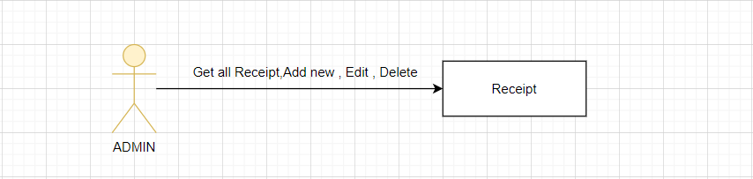

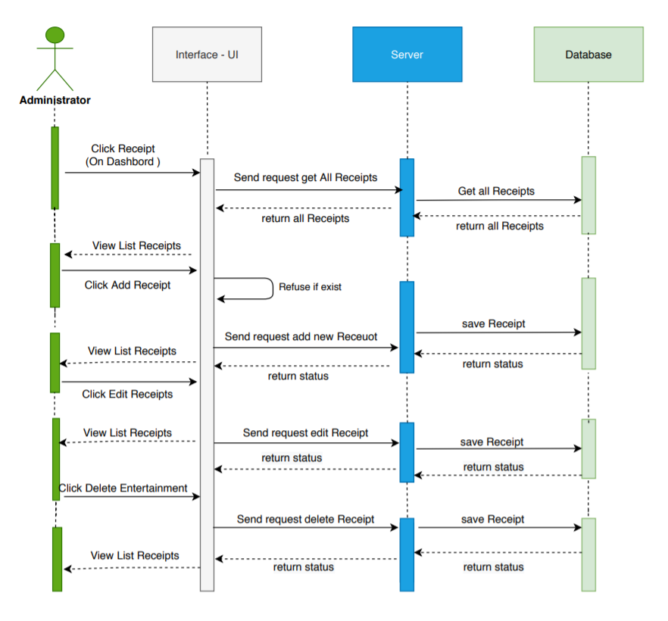

* **View Receipt :**

|  |  |  |
| --- | --- | --- |
| **Use Case Name** | View Receipt List | |
| **Actors** | Admin | |
| **Description** | Admin wants to view Receipt List. | |
| **Requirements** | Admin clicks ‘Receipt in navbar. | |
| **Pre-conditions** | Logged in with role Admin. | |
| **Post-conditions** | Success: Receipt page is opened. | |
| **Basic flow** | **Actor Actions** | **System Responses** |
|  | 1.   * Administrator: move the cursor to Receipt and click on the Receipt link in navbar. | 2. System opens Receipt List page with the information of the current account:   * Receipt List :   + Pay Date   + Sub total   + Tax   + Total   + Pay Status   + Update button   + Delete button |
| **Alternative flow** |  |  |
| **Exception** |  |  |

* **Update Receipt :**

|  |  |  |
| --- | --- | --- |
| **Use Case Name** | Update Receipt | |
| **Actors** | Admin | |
| **Description** | Admin wants to change Receipt profile . | |
| **Requirements** | Admin changes current information and clicks Save changes. | |
| **Pre-conditions** |  | |
| **Post-conditions** | Success: Return to Receipt List page. | |
| **Basic flow** | Admin Actions:  1. To change Receipt details, actor changes information in the form below:   * Receipt Update form :   + Pay Status textfield * Update button   Clicks Save Update | System Responses:  2. Systems updates new information to database, show ‘Profile is updated’ message and returns to Receipt page. |

#### **Feedbacks :**

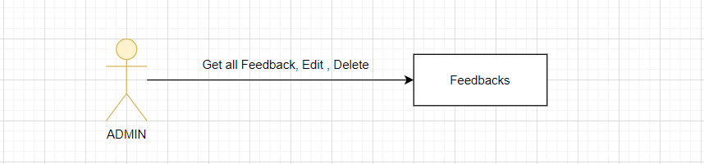

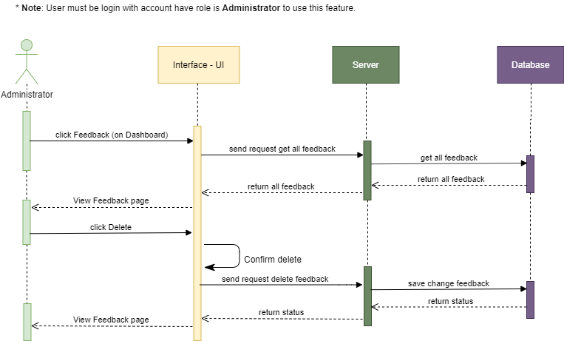

* **View Feedback** :

|  |  |  |
| --- | --- | --- |
| **Use Case Name** | View Feedback List | |
| **Actors** | Admin | |
| **Description** | Admin wants to view Feedback List. | |
| **Requirements** | Admin clicks ‘Feedback in navbar. | |
| **Pre-conditions** | Logged in with role Admin. | |
| **Post-conditions** | Success: Receipt page is opened. | |
| **Basic flow** | **Actor Actions** | **System Responses** |
|  | 1.   * Administrator: move the cursor to Feedback and click on the Feedback link in navbar. | 2. System opens Feedback List page with the information of the current account:   * Feedback List :   + Feedback Message   + QrCode   + Feedback Time   + Update button   + Delete button |
| **Alternative flow** |  |  |
| **Exception** |  |  |

#### **Employee sequence diagrams :**

1. **Customers :**

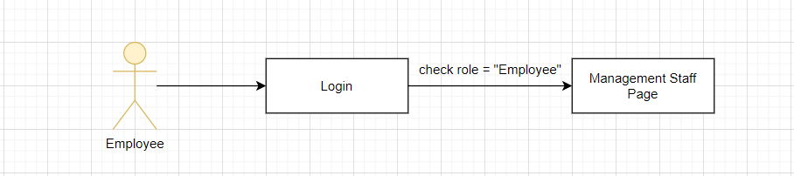

#### 

1. **Receipt :**

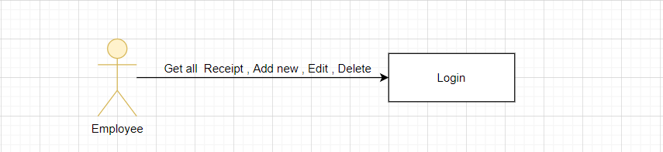

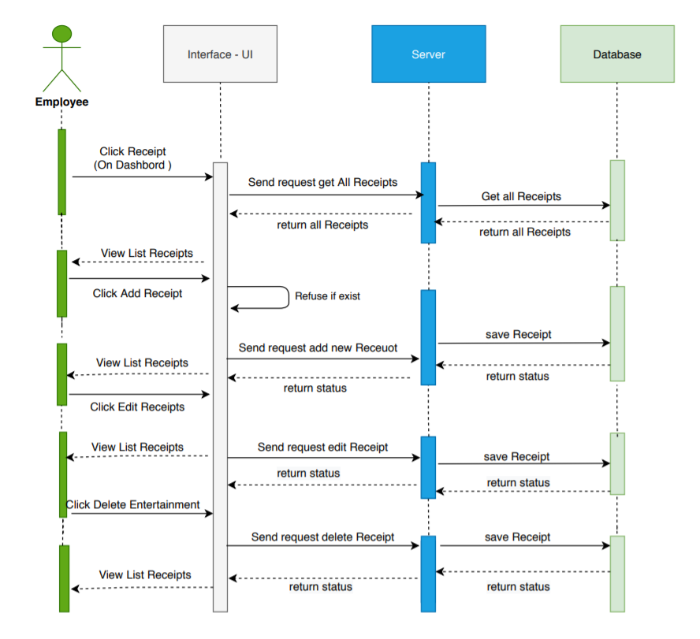

## DATABASE DESIGN :

## Logical design (Entity Relationship Diagram) :

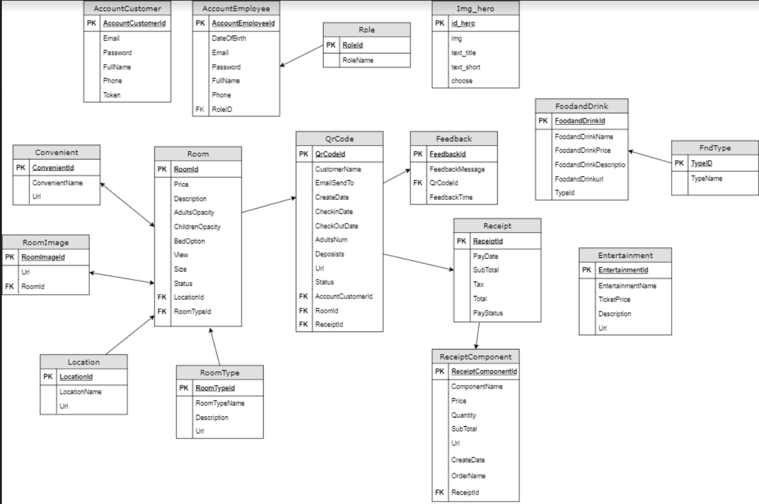

TASK SHEET REVIEW 2

|  |  |  |  |  |  |  |  |
| --- | --- | --- | --- | --- | --- | --- | --- |
| Project Ref. No.:  eP/Advertisement Portal Management System/01 | | Project Title: | Activity Plan Prepared By: | Date of Preparation of Activity Plan: | | | |
| No. | Task | Actual Start Date | Actual Days | Team Mate Names | Status |
| 1 | Architecture & Design of Project | Resort Management | Bao | 12/07/2020 | 2 | All Member | Completed |
| 2 | Use Case Diagram | 13/07/2020 | 1 | All Member | Completed |
| 3 | Sequence diagrams | 15/07/2020 | 2 | All Member | Completed |
| 4 | Database design | 17/07/2020 | 2 | All Member | Completed |
| 5 | Task Sheet review 2 | 17/07/2020 | 1 | Thai | Completed |

|  |  |
| --- | --- |
| **Date: 17/07/2020** | |
| Signature of Instructor:  **Mr. Tran Phuoc Sinh** | Signature of Team Leader:  **Trinh Thiem Bao** |

**REVIEW 3**

## Database Design :

#### **Database design diagram :**

## 

1. **Database Structure :**

##### **Table AccountCustomer :**

| No | Field Name | Data Type | Allow  Null | Default | Key | Reference Table | Description |
| --- | --- | --- | --- | --- | --- | --- | --- |
| 1 | AccountCustomerId | int | No | Identity(1,1) | PK |  | AccountCustomer ID |
| 2 | Email | varchar(100) | Yes |  |  |  | Email |
| 3 | FullName | varchar(255) | Yes |  |  |  | AccountCustomer Name |
| 4 | Password | varchar(255) | Yes |  |  |  | Password |
| 5 | Phone | varchar(255) | Yes |  |  |  | Customer phone |
| 6 | Token | varchar(255) | Yes |  |  |  | Token |

##### **Table AccountEmployee :**

| No | Field Name | Data Type | Allow  Null | Default | Key | Reference Table | Description |
| --- | --- | --- | --- | --- | --- | --- | --- |
| 1 | AccountId | int | No | Identity(1,1) | PK |  | AccountEmployee ID |
| 2 | DateOfBirth | datetime | Yes |  |  |  | Date of birth |
| 3 | Email | varchar(255) | Yes |  |  |  | AccountCustomer Name |
| 4 | Password | varchar(255) | Yes |  |  |  | Password |
| 5 | Fullname | varchar(255) | Yes |  |  |  | Employee Name |
| 6 | Phone | varchar(255) | Yes |  |  |  | Employee Phone |
| 7 | RoleId | Int | Yes |  | FK | Role |  |

##### **Table Convenient :**

| No | Field Name | Data Type | Allow  Null | Default | Key | Reference Table | Description |
| --- | --- | --- | --- | --- | --- | --- | --- |
| 1 | ConvenientId | int | No | Identity(1,1) | PK |  | Covenient ID |
| 2 | ConvenientName | Varchar(50) | Yes |  |  |  | Convenient Name |
| 3 | Url | varchar(255) | Yes |  |  |  | Link of Img |

##### **Table Entertainment :**

| No | Field Name | Data Type | Allow  Null | Default | Key | Reference Table | Description |
| --- | --- | --- | --- | --- | --- | --- | --- |
| 1 | EntertainmentId | int | No | Identity(1,1) | PK |  | Entertainment ID |
| 2 | EntertainmentName | varchar(255) | Yes |  |  |  | EntertainmentName |
| 3 | TicketPrice | float | Yes |  |  |  | Price of Ticket |
| 4 | EntertainmentDescription | varchar(255) | Yes |  |  |  | Description Of Entertainment |
| 5 | Url | varchar(500) | Yes |  |  |  | Link of Image |

##### **Table Feedbacks :**

| No | Field Name | Data Type | Allow  Null | Default | Key | Reference Table | Description |
| --- | --- | --- | --- | --- | --- | --- | --- |
| 1 | FeedbackId | int | No | Identity(1,1) | PK |  | ID of Feedbacks |
| 2 | FeedbackMessage | varchar(255) | Yes |  |  |  | Message of Feedback |
| 3 | QrCodeId | Varchat(255) | Yes |  | FK | Qrcode |  |

##### **Table fndType :**

| No | Field Name | Data Type | Allow  Null | Default | Key | Reference Table | Description |
| --- | --- | --- | --- | --- | --- | --- | --- |
| 1 | TypeId | int | No | Identity(1,1) | PK |  | ID of fndType |
| 2 | TypeName | varchar(255) | Yes |  |  |  | Name of fndType |

##### **Table Food and Drink :**

| No | Field Name | Data Type | Allow  Null | Default | Key | Reference Table | Description |
| --- | --- | --- | --- | --- | --- | --- | --- |
| 1 | FoodAndDrinkId | int | No | Identity(1,1) | PK |  | ID of FoodAndDrink |
| 2 | FoodAndDrinkName | Varchat(50) | Yes |  |  |  | Name of FoodAndDrink |
| 3 | FoodAndDrinkPrice | float | Yes |  |  |  | Price of FoodAndDrink |
| 4 | FoodAndDrinkDescription | varchar(255) | Yes |  |  |  | Details FAD |
| 5 | FoodAndDrinkUrl | varchar(255) | Yes |  |  |  | Url image of FAD |
| 6 | TypeId | int | Yes |  | FK | fndType | TypeId |

##### **Table Location :**

| No | Field Name | Data Type | Allow  Null | Default | Key | Reference Table | Description |
| --- | --- | --- | --- | --- | --- | --- | --- |
| 1 | LocationId | int | No | Identity(1,1) | PK |  | ID of Location |
| 2 | LocationName | varchar(50) | Yes |  |  |  | Name of Location |
| 3 | LocationUrl | Varchat(500) | Yes |  |  |  | Url image of Location |

##### **Table QrCode :**

| No | Field Name | Data Type | Allow  Null | Default | Key | Reference Table | Description |
| --- | --- | --- | --- | --- | --- | --- | --- |
| 1 | QrCodeId | Varchar(255) | No |  | PK |  | ID of QrCode |
| 2 | CustomerName | Varchar(50) | Yes |  |  |  | Name of Customer |
| 3 | EmailSendTo | varchar(255) | Yes |  |  |  | Email of Customer send code |
| 4 | CreateDate | datetime | Yes |  |  |  | Time create Qrcode |
| 5 | CheckInDate | datetime | Yes |  |  |  | Checkin Date |
| 6 | CheckOutDate | datetime | Yes |  |  |  | CheckOut Date |
| 7 | AdultsNum | Int | Yes |  |  |  | Number of Adults in Room |
| 8 | Deposists | float | Yes |  |  |  | Deposists |
| 9 | Url | Varchar(255) | Yes |  |  |  | Url link image |
| 10 | Status | bit | Yes |  |  |  | Active or not active |
| 11 | AccountCustomerId | Int | Yes |  | FK | AccountCustomer | CustomerId |
| 12 | RoomId | Int | Yes |  | FK | Room | Room ID |
| 13 | ReceiptId | int | Yes |  | FK | Receipt | Receipt ID |

##### **Table Receipt :**

| No | Field Name | Data Type | Allow  Null | Default | Key | Reference Table | Description |
| --- | --- | --- | --- | --- | --- | --- | --- |
| 1 | ReceiptId | int | No | Identity(1,1) | PK |  | ID of Receipt |
| 2 | PayDate | datetime | Yes |  |  |  | Date of Pay |
| 3 | Subtotal | float | Yes |  |  |  | Sub Total |
| 4 | Tax | float | Yes |  |  |  | Tax of Receipt |
| 5 | Total | float | Yes |  |  |  | Total of Receipt |
| 6 | PayStatus | bit | Yes |  |  |  | Status of Pay |

##### **Table ReceiptComponent :**

| No | Field Name | Data Type | Allow  Null | Default | Key | Reference Table | Description |
| --- | --- | --- | --- | --- | --- | --- | --- |
| 1 | ReceiptComponentID | int | No | Identity(1,1) | PK |  | ID of ComponentReceipt |
| 2 | ComponentName | Varchar(100) | Yes |  |  |  | Name of Component |
| 3 | OrdererName | varchar(100) | Yes |  |  |  | Name of Oderer |
| 4 | Price | float | Yes |  |  |  | Price |
| 5 | Quantity | int | Yes |  |  |  | Quantity order |
| 6 | OrderDate | datetime | Yes |  |  |  | Order Date |
| 7 | Url | Varchat(500) | Yes |  |  |  | Url |
| 8 | Subtotal | float | Yes |  |  |  | Sub total of Order |
| 9 | ReceiptID | int | Yes |  | FK | Receipt | Receipt ID |

##### **Table Role :**

| No | Field Name | Data Type | Allow  Null | Default | Key | Reference Table | Description |
| --- | --- | --- | --- | --- | --- | --- | --- |
| 1 | RoleId | int | No | Identity(1,1) | PK |  | ID of Role |
| 2 | RoleName | Varchar(50) | Yes |  |  |  | Name of Role |

* **Table Room :**

| No | Field Name | Data Type | Allow  Null | Default | Key | Reference Table | Description |
| --- | --- | --- | --- | --- | --- | --- | --- |
| 1 | RoomId | int | No | Identity(1,1) | PK |  | ID of Room |
| 2 | AdultOpacity | int | Yes |  |  |  | Adult Opacity |
| 3 | ChildrenOpacity | int | Yes |  |  |  | Children Opacity |
| 4 | Price | float | Yes |  |  |  | Price of Room |
| 5 | Bed Option | Varchar(80) | Yes |  |  |  | Bed Option of Room |
| 6 | Description | Varchat(255) | Yes |  |  |  | Description of Room |
| 7 | Size | Int | Yes |  |  |  | Size of Room |
| 8 | View | Varchar(45) | Yes |  |  |  | View of Room |
| 9 | Status | bit | Yes |  |  |  | Status of Room |
| 10 | RoomTypeId | bit | Yes |  | FK | RoomType | RoomType ID |
| 11 | LocationId | Int | Yes |  | FK | Location | Location ID |

* **Table RoomImage :**

| No | Field Name | Data Type | Allow  Null | Default | Key | Reference Table | Description |
| --- | --- | --- | --- | --- | --- | --- | --- |
| 1 | RoomImageId | int | No | Identity(1,1) | PK |  | ID of RoomImage |
| 2 | Url | Varchar(500) | Yes |  |  |  | Url of Image |
| 3 | RoomId | int | Yes |  | FK | Room | Room ID |

* **Table RoomType :**

| No | Field Name | Data Type | Allow  Null | Default | Key | Reference Table | Description |
| --- | --- | --- | --- | --- | --- | --- | --- |
| 1 | RoomTypeId | int | No | Identity(1,1) | PK |  | ID of Room Type |
| 2 | RoomTypeName | Varchar(50) | Yes |  |  |  | Name Of Room Type |
| 3 | Description | Varchar(500) | Yes |  |  |  | Description Room Type |
| 4 | Url | Varchar(500) | YES |  |  |  | Url of Image Room Type |

## GUI DESIGN :

1. **User Interface :**

#### **Home Page**: Introduce the website with the navigation bar links. Some Hot Locations link showed on this page.

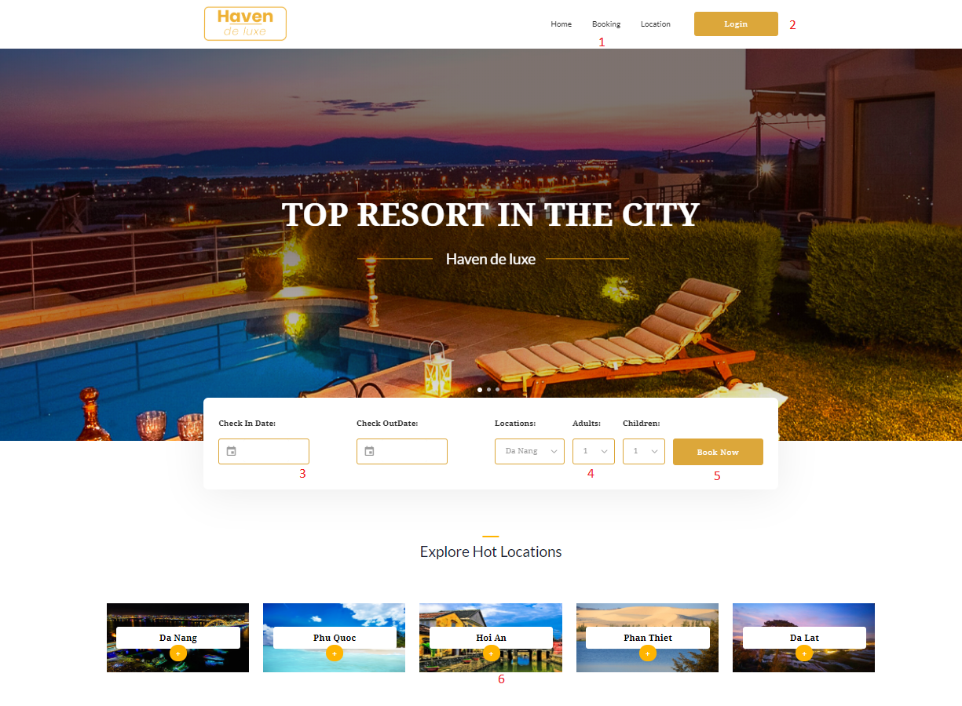

|  |  |  |  |  |  |
| --- | --- | --- | --- | --- | --- |
| No | Name | Type | Event | Description | Status |
| 1 | Navigation bar | Hyperlink | Click | Choose & click to go to sub pages | Enable |
| 2 | Login | Hyperlink | Click | Click to go to Login page | Enable |
| 3 | Checkin-Checkout | Datetime | Click | Click and choose Checkin-Checkout date | Enalbe |
| 4 | Choose Option | Dropdown List | Click | Click and choose your option for booking | Enalbe |
| 5 | Book Now | Button | Click | Click Button to filter the room | Enalbe |
| 6 | Location | HyperLink | Click | Click to go to Location page | Enalbe |

1. **Booking Page** :

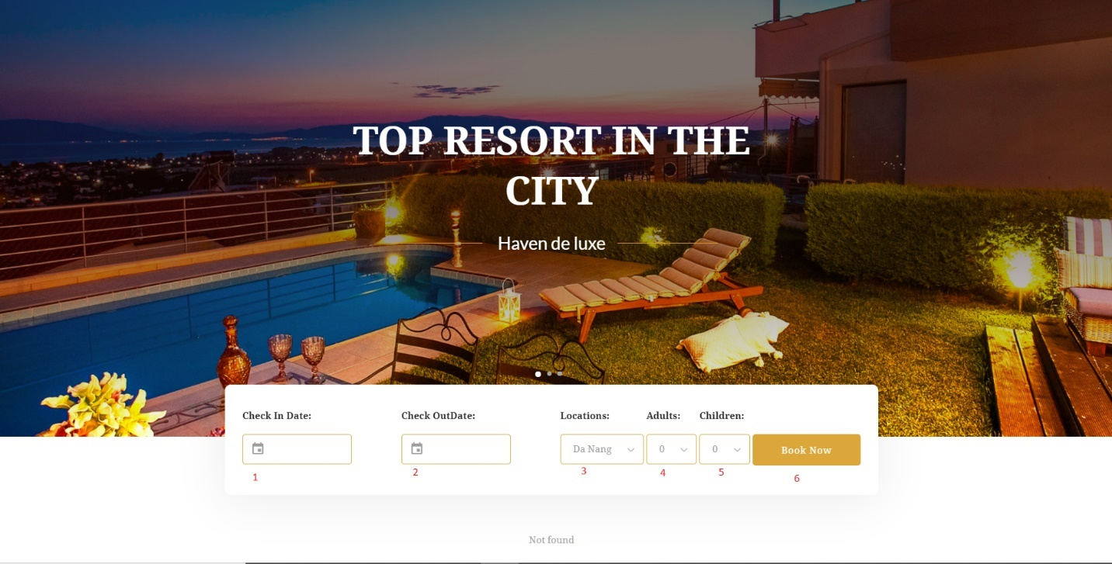

|  |  |  |  |  |  |
| --- | --- | --- | --- | --- | --- |
| No | Name | Type | Event | Description | Status |
| 1 | Checkin | Datetime | Click | Click and choose your Checkin Date | Enable |
| 2 | Checkout | Datetime | Click | Click and choose your CheckOut Date | Enable |
| 3 | Location | Dropdown  List | Click | Click and choose Location Booking | Enalbe |
| 4 | Adults | Dropdown List | Click | Click and choose number of Adults | Enalbe |
| 5 | Children | Dropdown List | Click | Click and choose number of Children | Enalbe |
| 6 | Book Now | Button | Click | Click Button to filter rooms | Enalbe |

* Note : **Only show the room when the customer selects the option**

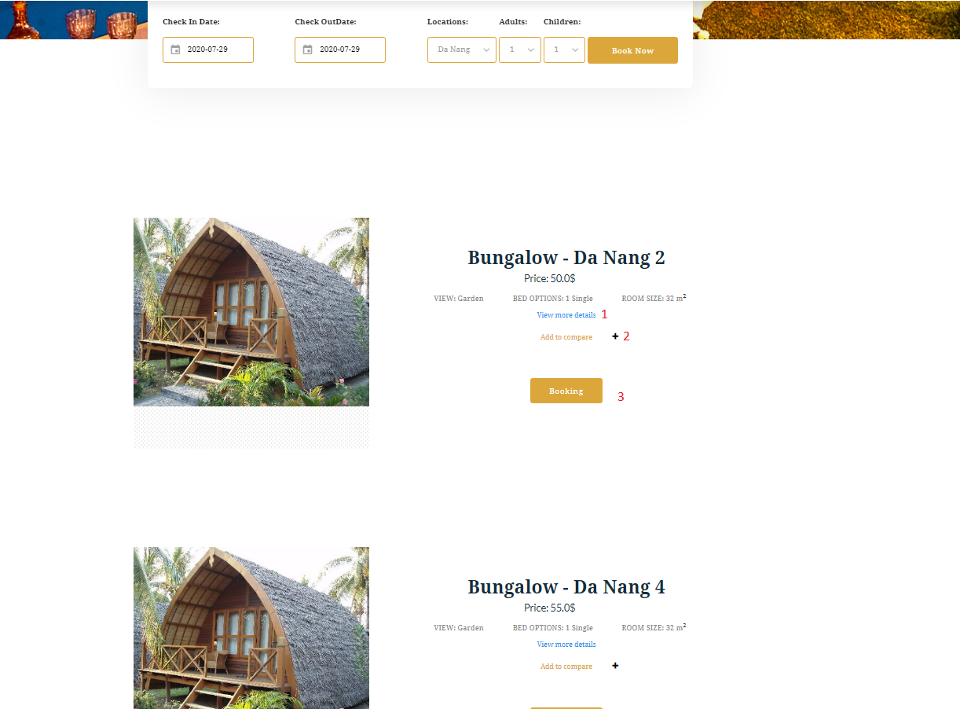

|  |  |  |  |  |  |
| --- | --- | --- | --- | --- | --- |
| No | Name | Type | Event | Description | Status |
| 1 | View more details | Button | Click | Click and display Model Box Details of Room | Enable |
| 2 | Add to compare | Button | Click | Click Button and another Button you want to compare | Enable |
| 3 | Booking | HyperLink | Click | Click to go to Cart | Enalbe |

1. **Cart for Booking Page (not Logged in ) :**

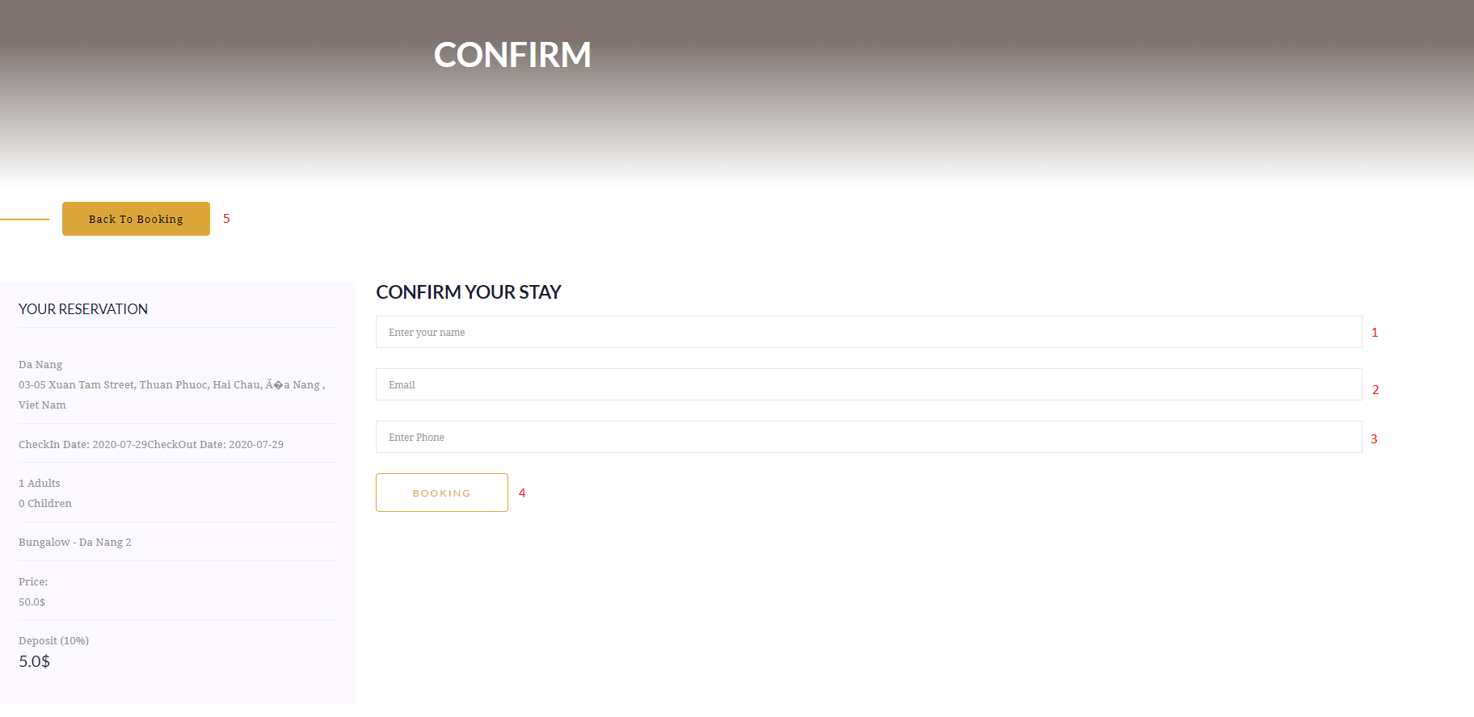

|  |  |  |  |  |  |  |
| --- | --- | --- | --- | --- | --- | --- |
| No | Name | Type | Validation | Event | Description | Status |
| 1 | Full name | Textbox | - Not null  - Max length: 50 | Focus | Input Full name | Enable |
| 2 | Email | Email | - Not null  - Email address  - Max length: 100 | Focus | Input Email | Enable |
| 3 | Phone | Tel | - Not null  - Digits only  - Min length: 9  - Max length: 10 | Focus | Input phone number | Enable |
| 4 | Booking | Hyperlink |  | Click | Click to go to Paypal | Enable |
| 5 | Back | Hyperlink |  | Click | Click to send to back Booking Page | Enable |

1. **Cart for Booking ( Logged in ) :**

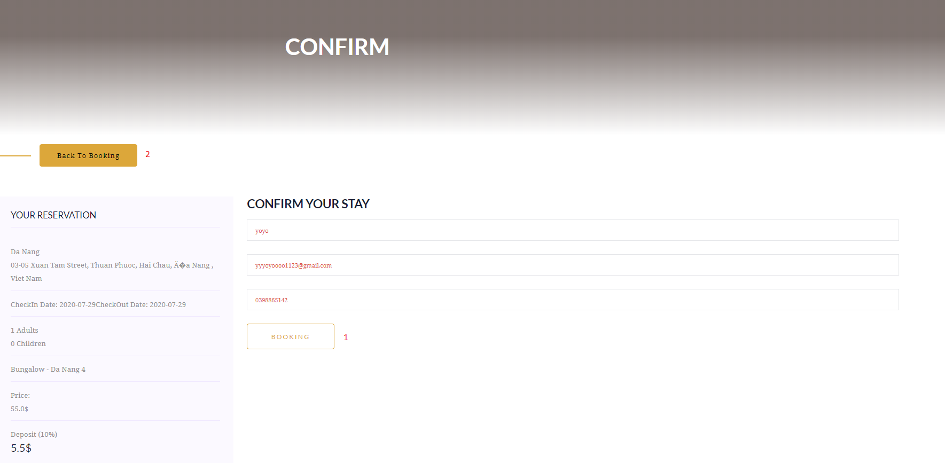

|  |  |  |  |  |  |
| --- | --- | --- | --- | --- | --- |
| No | Name | Type | Event | Description | Status |
| 1 | Booking | Hyperlink | Click | Click to go to PayPal | Enable |
| 2 | Back to Booking | Hyperlink | Click | Click to go back to Booking Page | Enable |

1. **Login Page :**

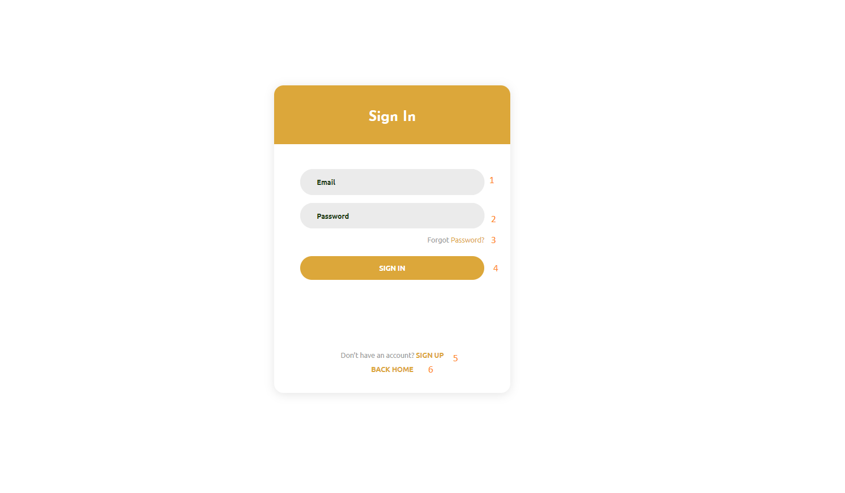

|  |  |  |  |  |  |  |
| --- | --- | --- | --- | --- | --- | --- |
| No | Name | Type | Validation | Event | Description | Status |
| 1 | Email | Email | - Not null  - Email address  - Max length: 100 | Focus | Input your Email | Enable |
| 2 | Password | Password | - Not null  - Max length: 50 | Focus | Input your Passwrod | Enable |
| 3 | Forgot Password | Hyperlink |  | Click | Click to go to Forgot Password Page | Enable |
| 4 | Sign In | Button |  | Click | Click Button and redirect to Haven Page | Enable |
| 5 | Sign Up | Hyperlink |  | Click | Click to go to Sign Up Page | Enable |
| 6 | Back Home | Hyperlink |  | Click | Click to go back to Haven Page |  |

1. **Sign Up Page :**

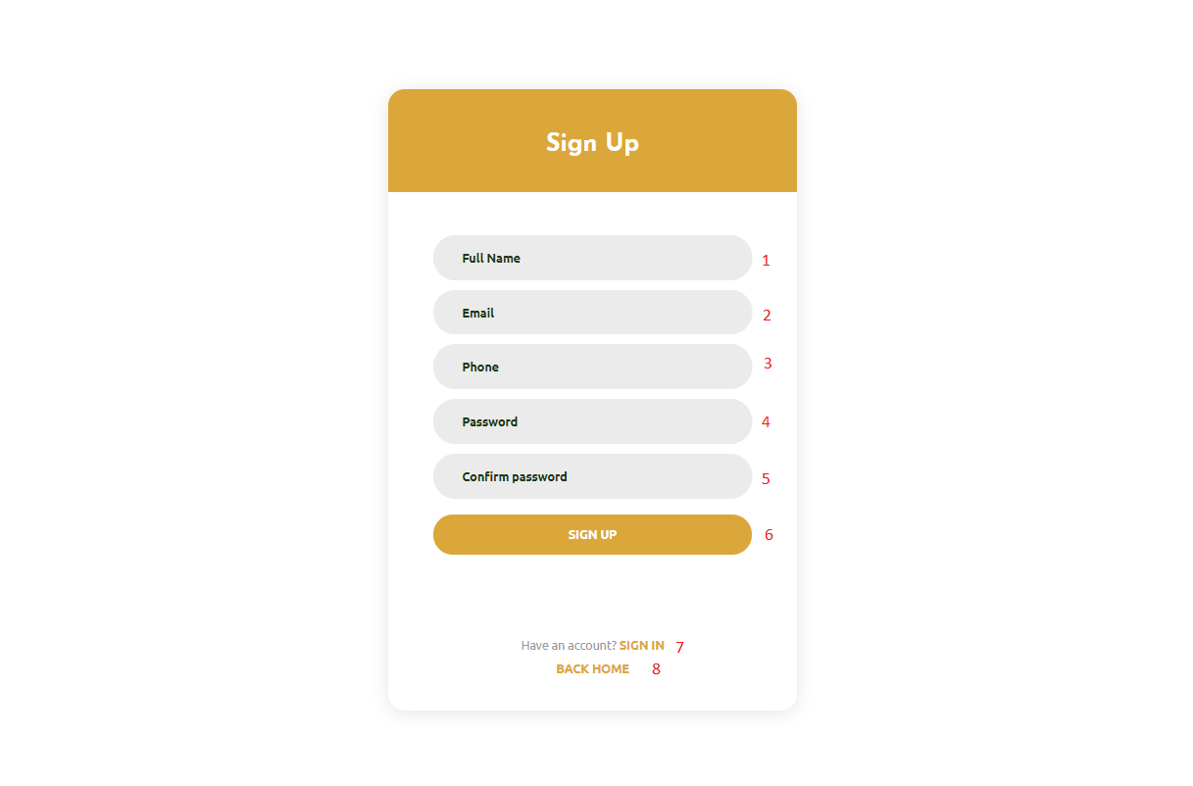

|  |  |  |  |  |  |  |
| --- | --- | --- | --- | --- | --- | --- |
| No | Name | Type | Validation | Event | Description | Status |
| 1 | Full Name | Textbox | - Not null  - Min length: 6  - Max length: 50 | Focus | Input Full Name | Enable |
| 2 | Email | Email | - Not null  - Max length: 100 | Focus | Input Email | Enable |
| 3 | Phone | Textbox | - Not null  - Digits only  - Length: 9 | Focus | Input Phone | Enable |
| 4 | Password | Password | - Not null  - Min length: 6  - Max length: 50 | Focus | Input Password |  |
| 5 | Confirm Password | Password | - Not null  - Min length: 6  - Max length: 50 | Focus | Input Confirm Password |  |
| 6 | Sign Up | Button |  | Click | Click Button and redirect to Login Page | Enable |
| 7 | Sign In | Hyperlink |  | Click | Click to go to Login Page | Enable |
| 8 | Back Home | Hyperlink |  | Click | Click to go back to Haven Page |  |

1. **Customer Page :**

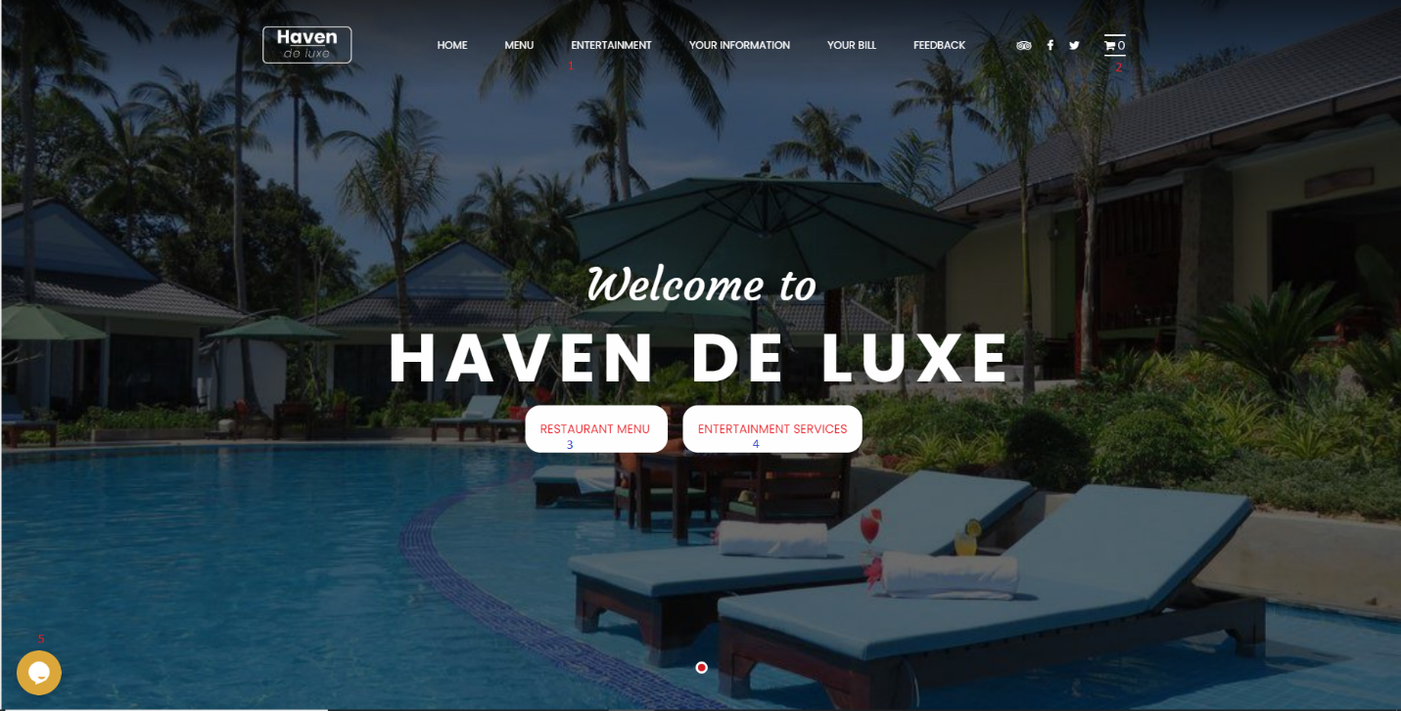

|  |  |  |  |  |  |
| --- | --- | --- | --- | --- | --- |
| No | Name | Type | Event | Description | Status |
| 1 | Navigation bar | Hyperlink | Click | Choose & click to go to sub pages | Enable |
| 2 | Cart | Hyperlink | Click | Click to go to Cart Page | Enable |
| 3 | Restaurant Menu | Hyperlink | Click | Click to go to Restaurant Page | Enable |
| 4 | Entertainment | Hyperlink | Click | Click to go to Entertainment Page | Enable |
| 5 | Chat Icon | Hyperlink | Click | Click to go to Chat Page with Employee | Enable |

1. **Restaurant Menu Page :**

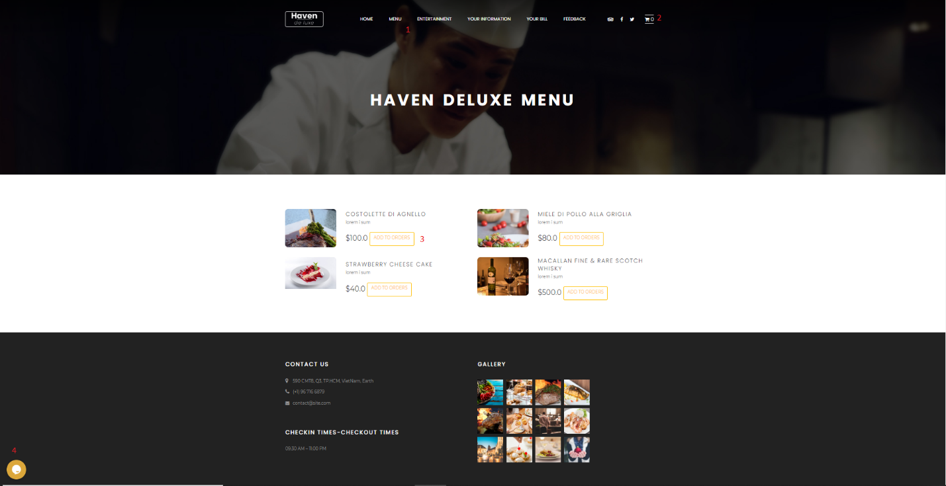

|  |  |  |  |  |  |
| --- | --- | --- | --- | --- | --- |
| No | Name | Type | Event | Description | Status |
| 1 | Navigation bar | Hyperlink | Click | Choose & click to go to sub pages | Enable |
| 2 | Cart Icon | Hyperlink | Click | Click to go to Cart Page | Enable |
| 3 | Add to Order | Button | Click | Click add to Order | Enable |
| 4 | Chat Icon | Button | Click | Click and input your chat with Employee | Enable |

1. **Entertainment Services Page :**

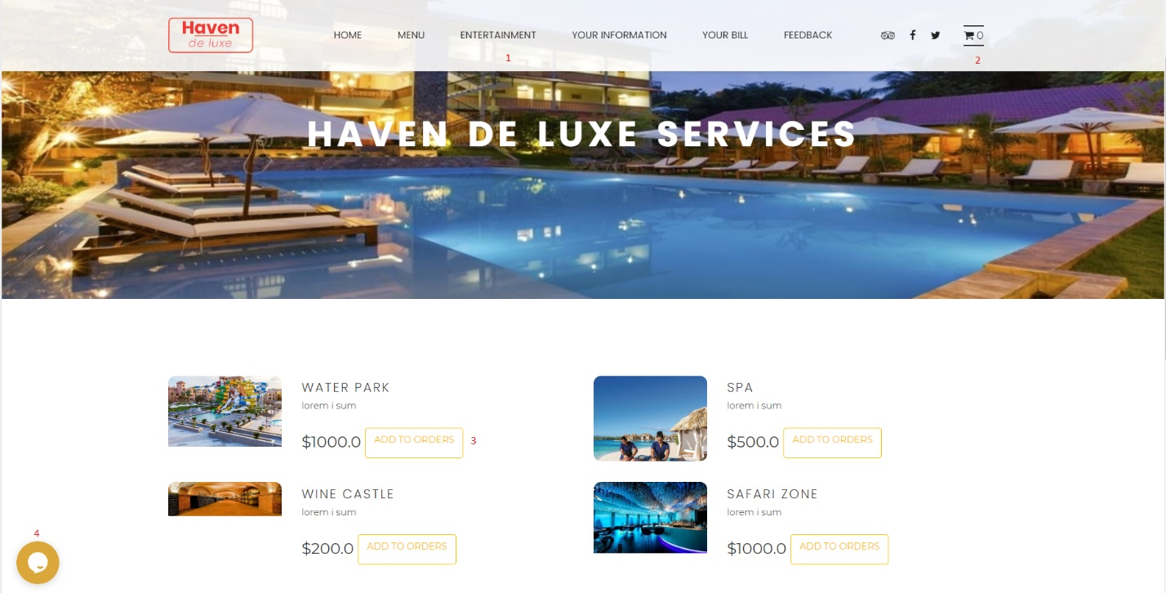

|  |  |  |  |  |  |
| --- | --- | --- | --- | --- | --- |
| No | Name | Type | Event | Description | Status |
| 1 | Navigation bar | Hyperlink | Click | Choose & click to go to sub pages | Enable |
| 2 | Cart Icon | Hyperlink | Click | Click to go to Cart Page | Enable |
| 3 | Add to Order | Button | Click | Click add to Order | Enable |
| 4 | Chat Icon | Button | Click | Click and input your chat with Employee | Enable |

1. **Information Customer Booked :**

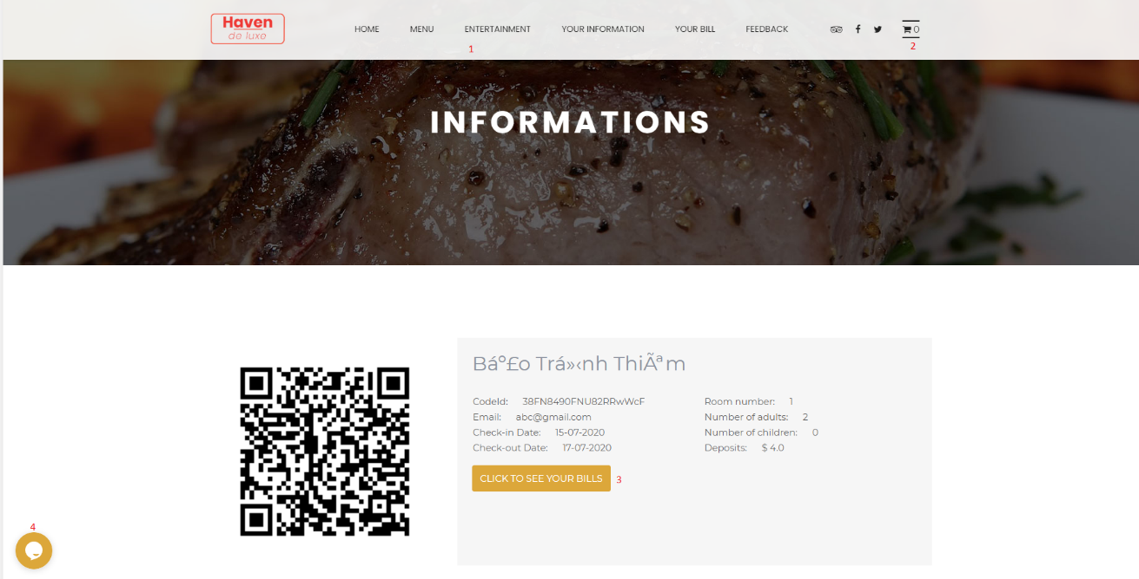

|  |  |  |  |  |  |
| --- | --- | --- | --- | --- | --- |
| No | Name | Type | Event | Description | Status |
| 1 | Navigation bar | Hyperlink | Click | Choose & click to go to sub pages | Enable |
| 2 | Cart Icon | Hyperlink | Click | Click to go to Cart Page | Enable |
| 3 | Click to see your bills | Hyperlink | Click | Click to go to Your Bill Page | Enable |
| 4 | Chat Icon | Button | Click | Click and input your chat with Employee | Enable |

1. **Your Bill Page :**

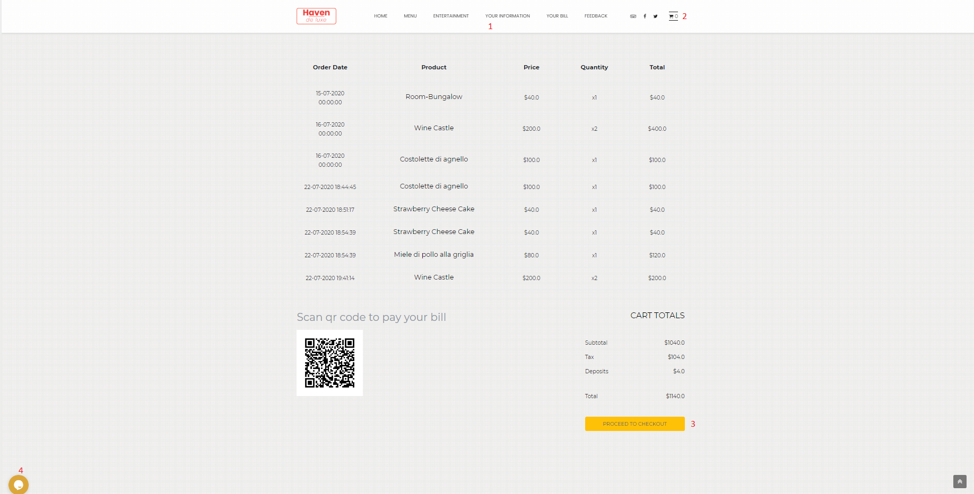

|  |  |  |  |  |  |
| --- | --- | --- | --- | --- | --- |
| No | Name | Type | Event | Description | Status |
| 1 | Navigation bar | Hyperlink | Click | Choose & click to go to sub pages | Enable |
| 2 | Cart Icon | Hyperlink | Click | Click to go to Cart Page | Enable |
| 3 | Proceed to checkout | Hyperlink | Click | Click to go to PayPal | Enable |
| 4 | Chat Icon | Button | Click | Click and input your chat with Employee | Enable |

1. **Feedback Page :**

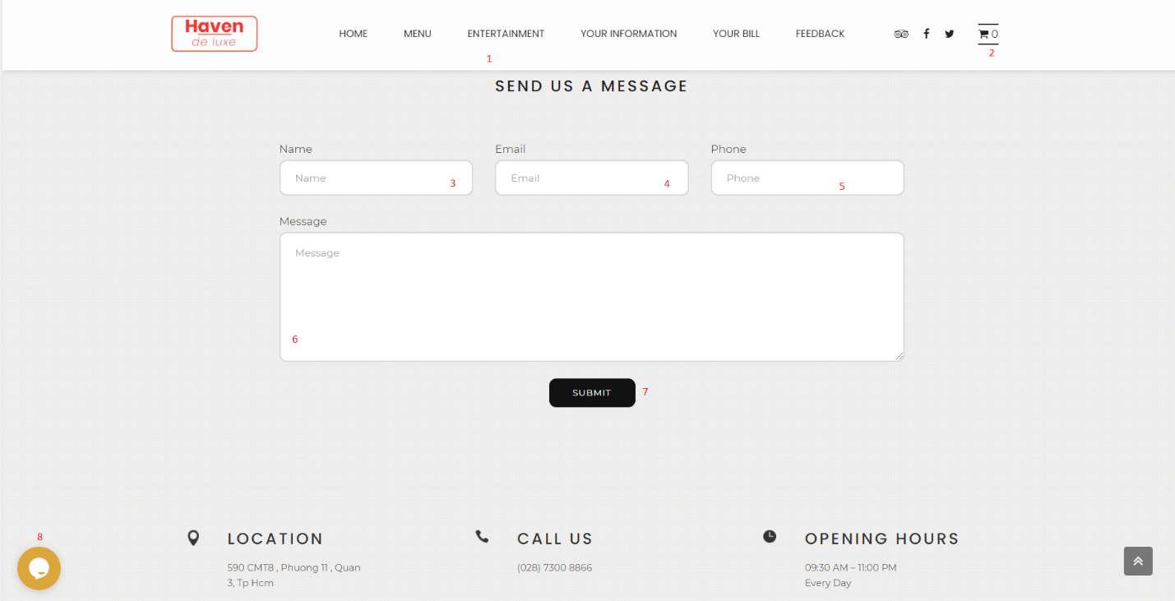

|  |  |  |  |  |  |  |
| --- | --- | --- | --- | --- | --- | --- |
| No | Name | Type | Validation | Event | Description | Status |
| 1 | Navigation bar | Hyperlink |  | Click | Choose & click to go to sub pages | Enable |
| 2 | Cart Icon | Hyperlink |  | Click | Click to go to Cart Page | Enable |
| 3 | Name | Textbox | - Not null  - Min length: 6  - Max length: 50 | Focus | Input Your Name | Enable |
| 4 | Email | Email | - Not null  - Min length: 6  - Max length: 100 | Focus | Input Email | Enable |
| 5 | Phone | Textbox | - Not null  - Digits only  - Length: 9 | Focus | Input Phone | Enable |
| 6 | Message | Textfield | - Min length: 1  - Max length: q000 | Click | Input your Feedback | Enable |
| 7 | Submit | Button |  | Click | Click Button Submit . Send Fb to Management | Enable |
| 8 | Chat Icon | Button |  | Click | Click and input your chat with Employee | Enable |

1. **Cart Page :**

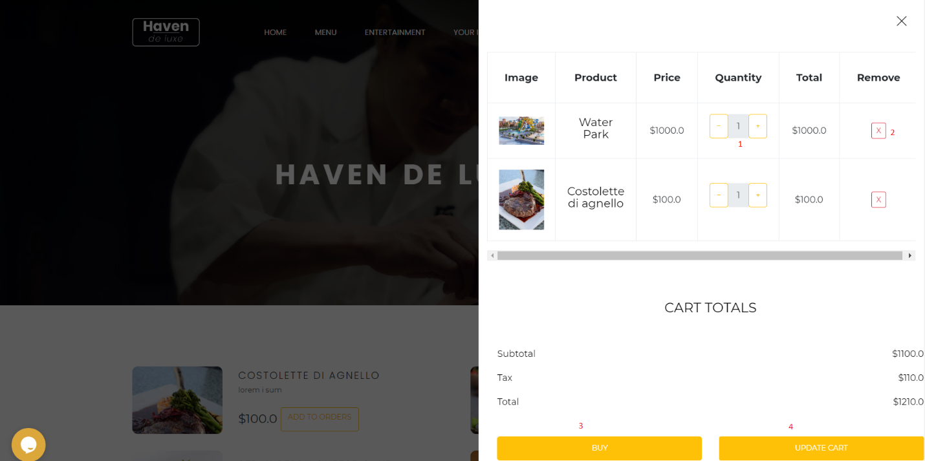

|  |  |  |  |  |  |
| --- | --- | --- | --- | --- | --- |
| No | Name | Type | Event | Description | Status |
| 1 | Quantity button | Button | Click | Choose & click quantity | Enable |
| 2 | Remove Icon | Button | Click | Click Delete icon for Delete Order | Enable |
| 3 | Button Buy | Button | Click | Click to go to PayPal | Enable |
| 4 | Update Cart | Button | Click | Click Button and Refresh your Cart | Enable |

1. **Admin Page :**
2. **Login Page :**

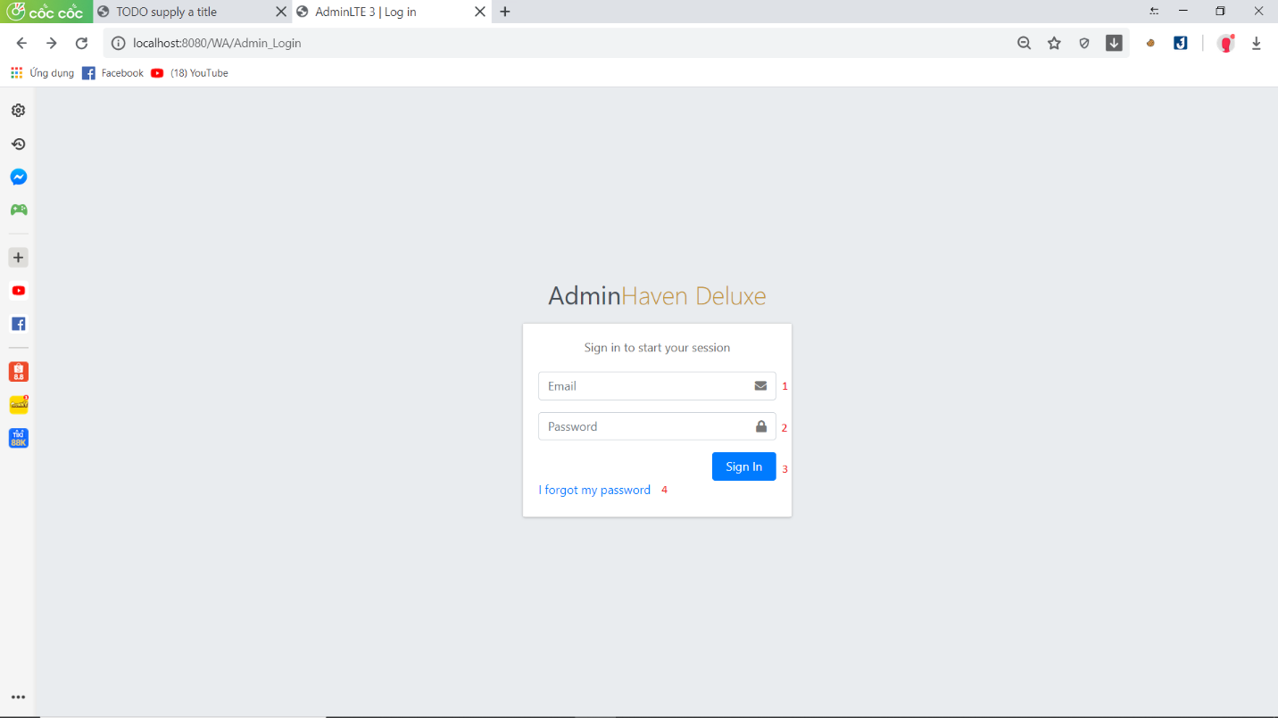

|  |  |  |  |  |  |  |
| --- | --- | --- | --- | --- | --- | --- |
| No | Name | Type | Validation | Event | Description | Status |
| 1 | Email | Email | - Not null  - Min length: 6  - Max length: 100 | Focus | Input Email | Enable |
| 2 | Password | Password | - Not null  - Min length: 6  - Length: 50 | Focus | Input Password | Enable |
| 3 | Sign in | Button |  | Click | Click Button Submit when role = “admin” Show Admin Page | Enable |
| 4 | I for got password | Hyperlink |  | Click | Click go to go forgot password page | Enable |

1. **Admin Page :**

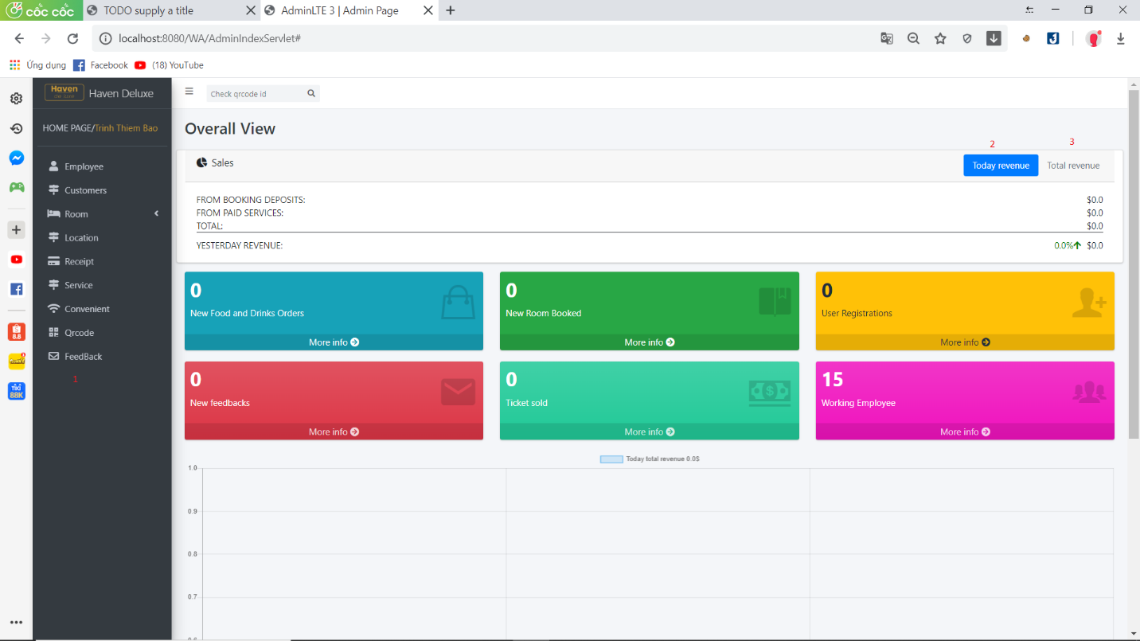

|  |  |  |  |  |  |
| --- | --- | --- | --- | --- | --- |
| No | Name | Type | Event | Description | Status |
| 1 | Nav bar | Hyperlink | Click | Choose & click to go to sub pages | Enable |
| 2 | Today Revenue | Button | Click | Click to see Revenue today | Enable |
| 3 | Total Revenue | Button | Click | Click to see total Revenue | Enable |

1. **Admin-Employee Page :**

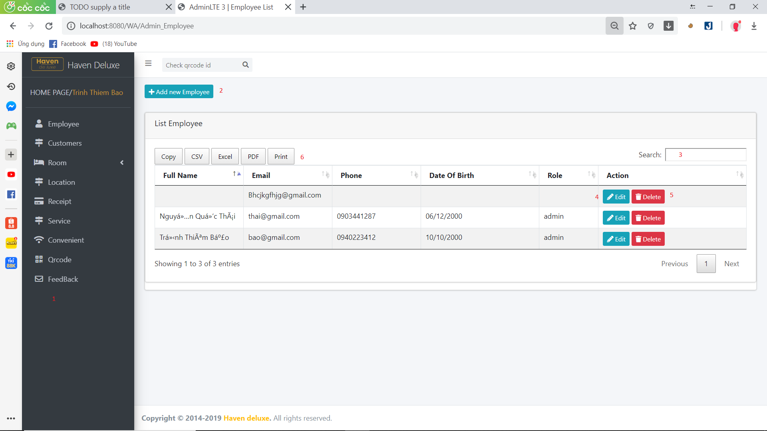

|  |  |  |  |  |  |
| --- | --- | --- | --- | --- | --- |
| No | Name | Type | Event | Description | Status |
| 1 | Nav bar | Hyperlink | Click | Choose & click to go to sub pages | Enable |
| 2 | Add new Employee | Hyperlink | Click | Click to go to Add Employee Page | Enable |
| 3 | Search | TextBox | Focus | Input value want to Seach | Enable |
| 4 | Edit | Hyperlink | Click | Click to go to Edit Page | Enable |
| 5 | Delete | Button | Click | Click the data you want to delete | Enable |
| 6 | PDF Button | Button | Click | Click PDF Button export file | Enable |

1. **Admin-Customer Page :**

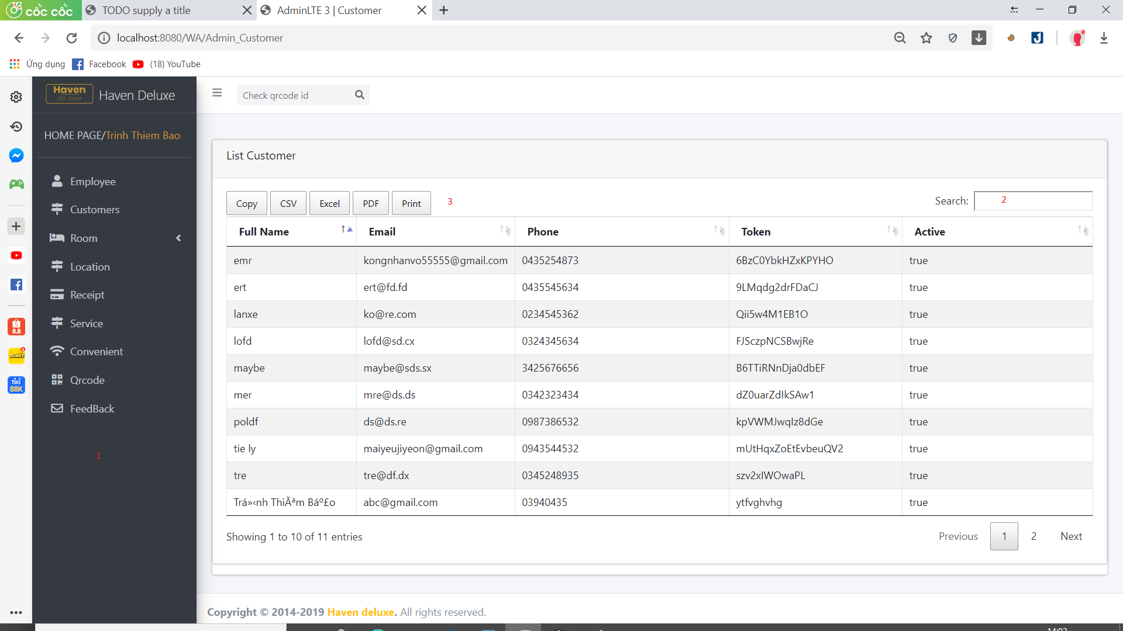

|  |  |  |  |  |  |
| --- | --- | --- | --- | --- | --- |
| No | Name | Type | Event | Description | Status |
| 1 | Nav bar | Hyperlink | Click | Choose & click to go to sub pages | Enable |
| 2 | Search | TextBox | Focus | Input value want to Search | Enable |
| 3 | PDF Button | Button | Click | Click PDF Button export file | Enable |

1. **Admin-RoomType :**

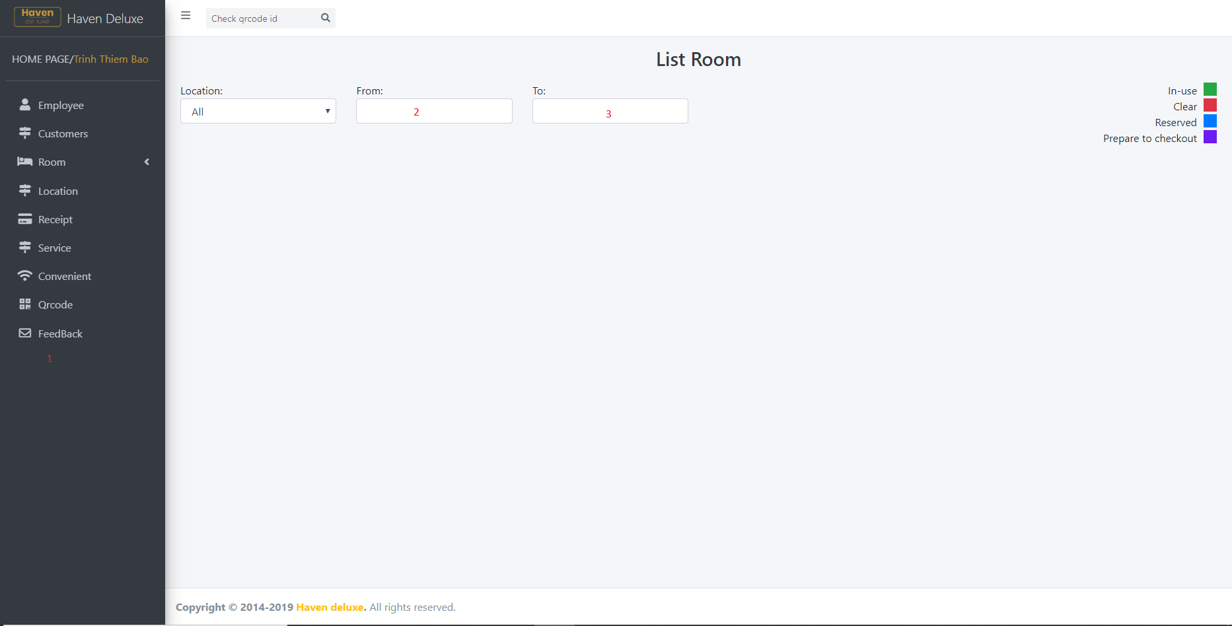

|  |  |  |  |  |  |
| --- | --- | --- | --- | --- | --- |
| No | Name | Type | Event | Description | Status |
| 1 | Nav bar | Hyperlink | Click | Choose & click to go to sub pages | Enable |
| 2 | Date From | Click | Click | Click and choose rooms want search | Enable |
| 3 | Date To | Click | Click | Click and choose rooms want search | Enable |

1. Admin-Location Page :

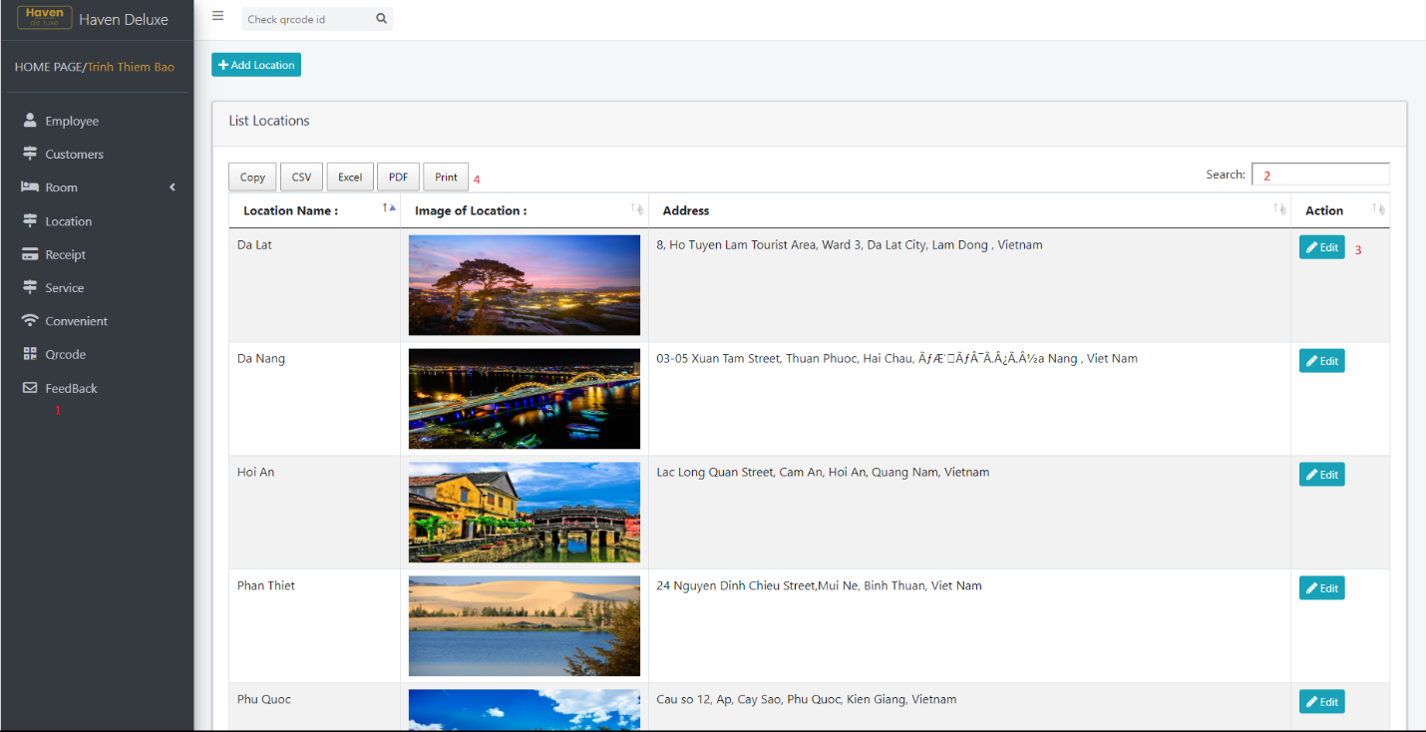

|  |  |  |  |  |  |
| --- | --- | --- | --- | --- | --- |
| No | Name | Type | Event | Description | Status |
| 1 | Nav bar | Hyperlink | Click | Choose & click to go to sub pages | Enable |
| 2 | Search | TextBox | Focus | Input value want to search | Enable |
| 3 | Edit | Button | Click | Click to go to Edit Location Pages | Enable |
| 4 | PDF Button | Button | Click | Click to export PDF File | Enable |

1. **Admin-Receipt Page :**

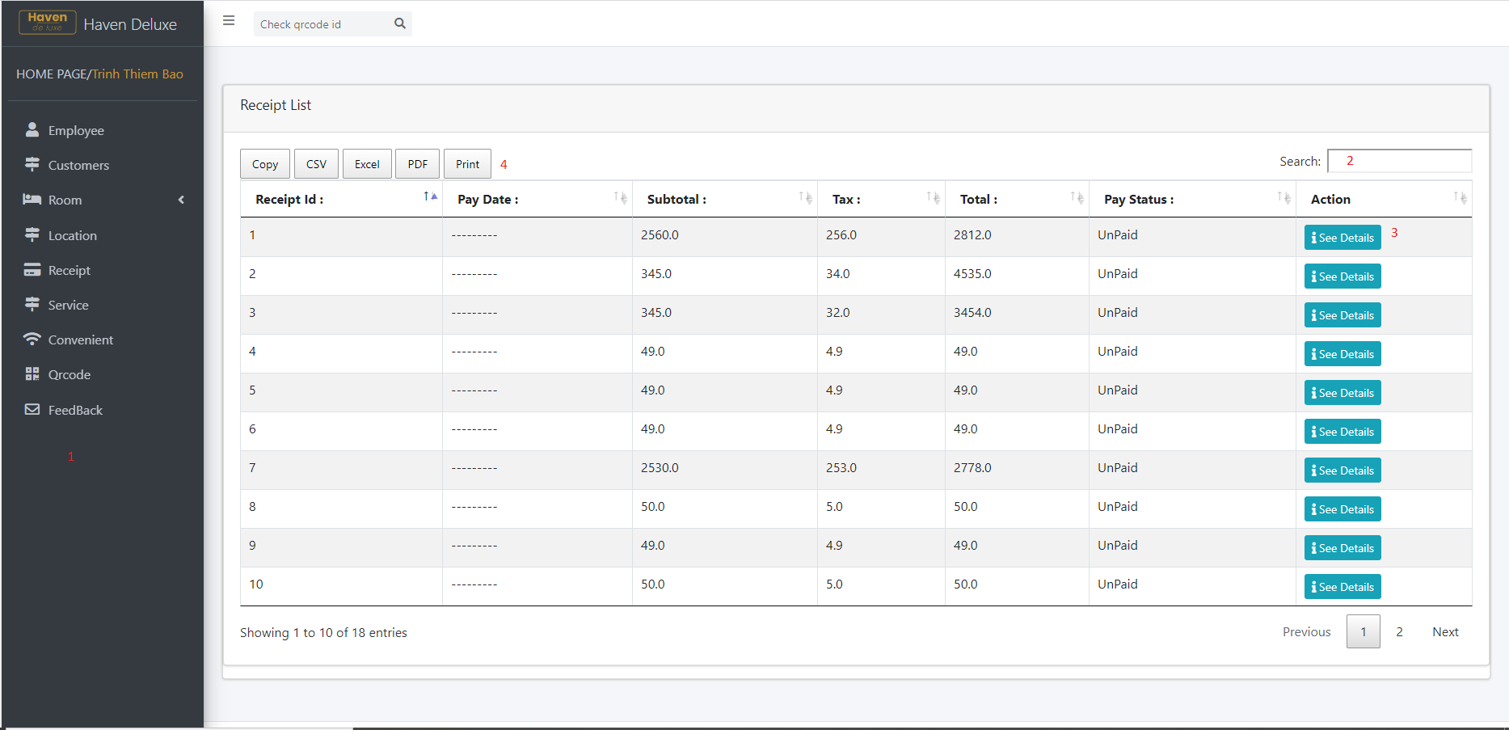

|  |  |  |  |  |  |
| --- | --- | --- | --- | --- | --- |
| No | Name | Type | Event | Description | Status |
| 1 | Nav bar | Hyperlink | Click | Choose & click to go to sub pages | Enable |
| 2 | Search | TextBox | Focus | Input value want to search | Enable |
| 3 | See Details | Hyperlink | Click | Click to go to Details Receipt Pages | Enable |
| 4 | PDF Button | Button | Click | Click to export PDF File | Enable |

1. **Admin-Service Page :**

|  |  |  |  |  |  |
| --- | --- | --- | --- | --- | --- |
| No | Name | Type | Event | Description | Status |
| 1 | Nav bar | Hyperlink | Click | Choose & click to go to sub pages | Enable |
| 2 | Edit | Hyperlink | Click | Click to go to Edit Pages | Enable |
| 3 | Delete | Button | Click | Click the data you want to delete | Enable |
| 4 | Search | TextBox | Focus | Input value want to search | Enable |
| 5 | PDF Button | Button | Click | Click to export PDF File | Enable |

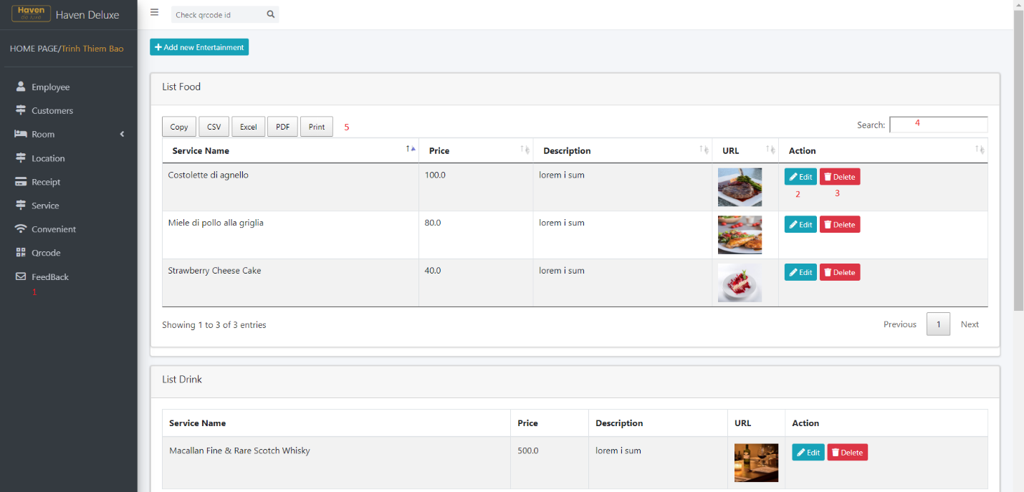

1. **Admin-Convenient Page :**

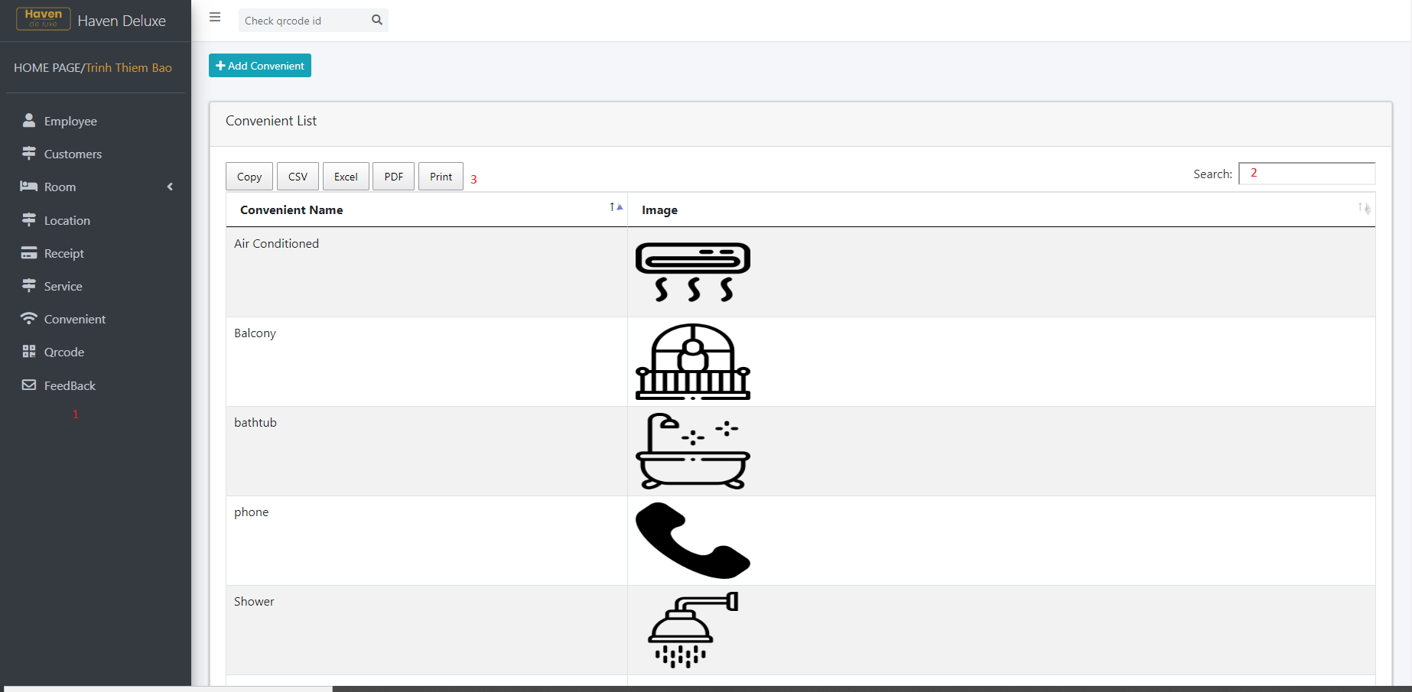

|  |  |  |  |  |  |
| --- | --- | --- | --- | --- | --- |
| No | Name | Type | Event | Description | Status |
| 1 | Nav bar | Hyperlink | Click | Choose & click to go to sub pages | Enable |
| 2 | Search | TextBox | Focus | Input value want to Search | Enable |
| 3 | PDF Button | Button | Click | Click PDF Button export file | Enable |

1. **Admin-QrCode Page :**

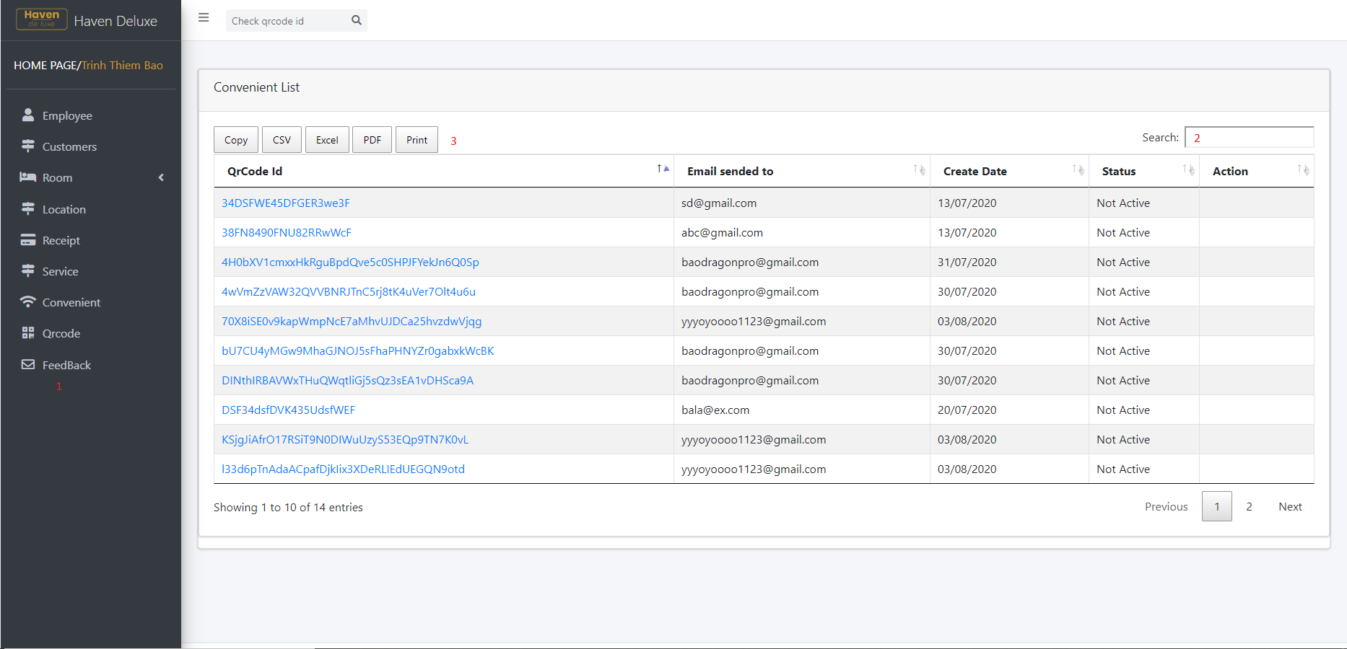

|  |  |  |  |  |  |
| --- | --- | --- | --- | --- | --- |
| No | Name | Type | Event | Description | Status |
| 1 | Nav bar | Hyperlink | Click | Choose & click to go to sub pages | Enable |
| 2 | Search | TextBox | Focus | Input value want to Search | Enable |
| 3 | PDF Button | Button | Click | Click PDF Button export file | Enable |

1. **Admin-Feedback Page :**

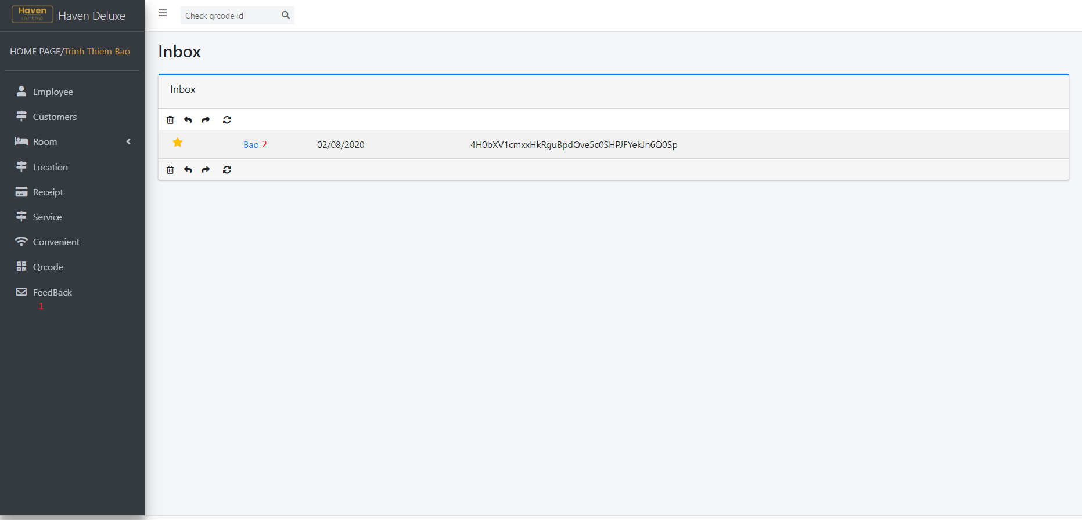

|  |  |  |  |  |  |
| --- | --- | --- | --- | --- | --- |
| No | Name | Type | Event | Description | Status |
| 1 | Nav bar | Hyperlink | Click | Choose & click to go to sub pages | Enable |
| 2 | CustomerName | Hyperlink | Click | Click to go to read Feedback | Enable |

1. **Employee Page :**
2. **Home Page :**

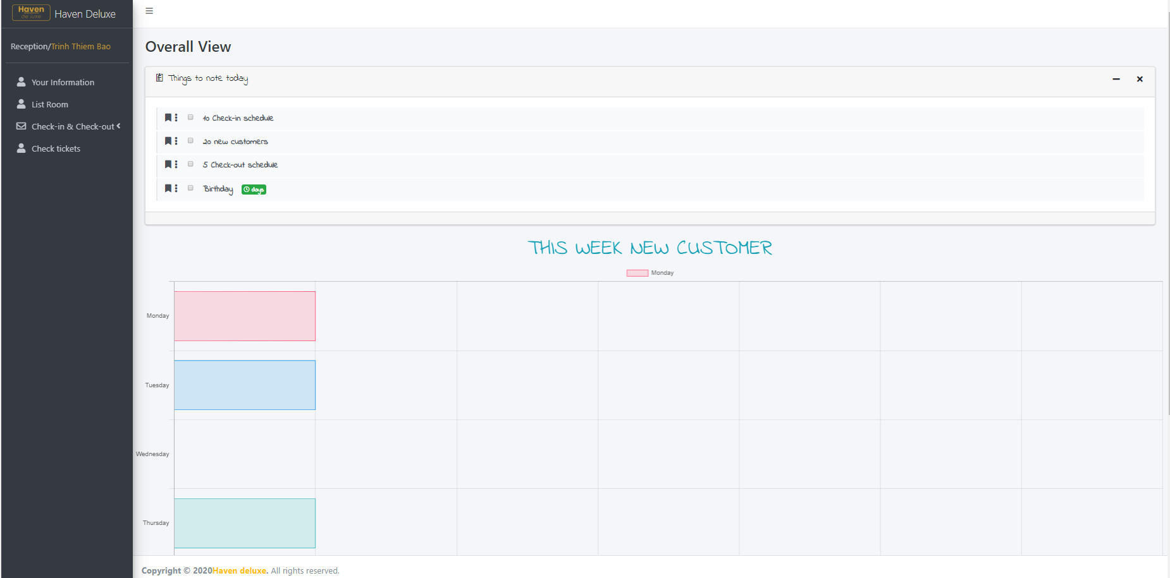

1. **Information Page :**

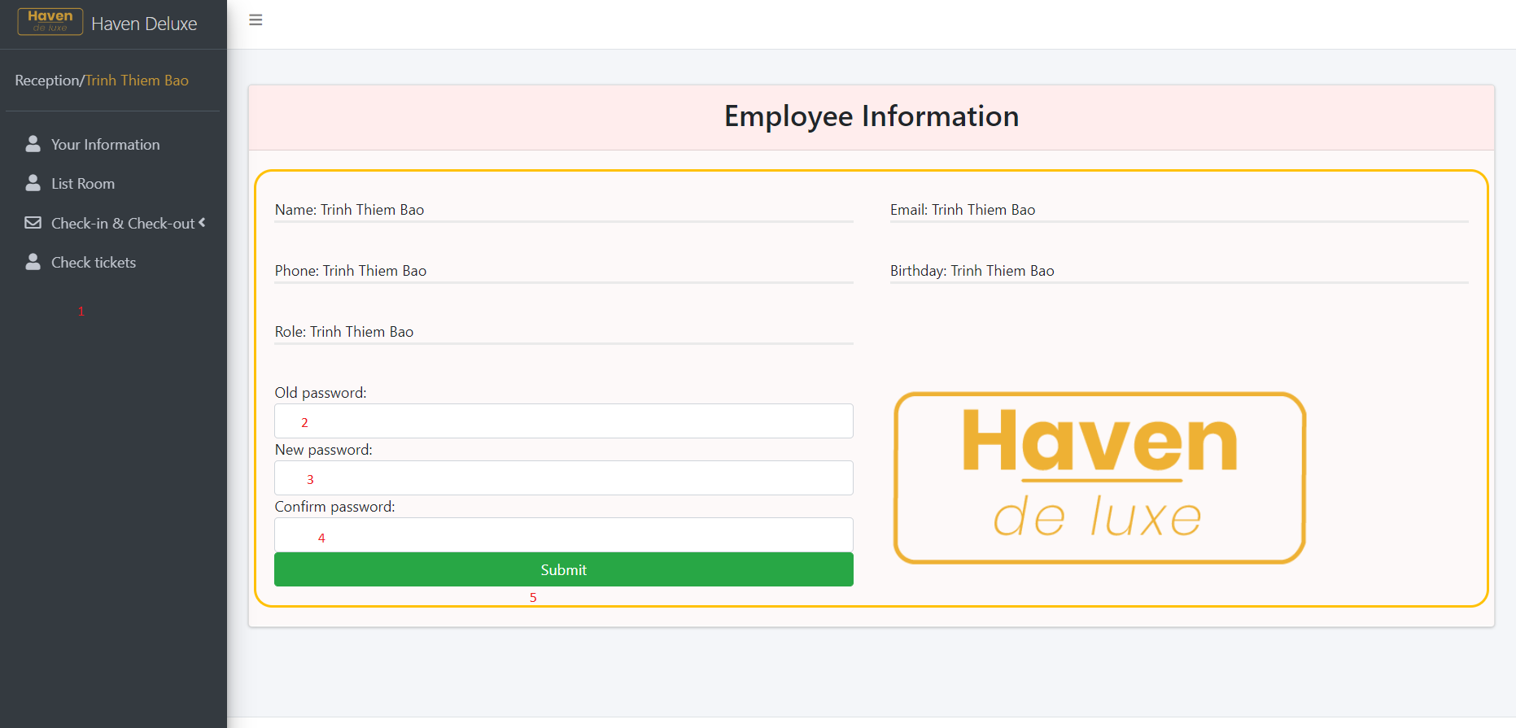

|  |  |  |  |  |  |  |
| --- | --- | --- | --- | --- | --- | --- |
| No | Name | Type | Validation | Event | Description | Status |
| 1 | Navbar | Hyper Link |  | Click | Choose & click to go to sub pages | Enable |
| 2 | Old Password | Password | - Not null  - Min length: 6  - Length: 50 | Focus | Input Old Password | Enable |
| 3 | New Password | Password | - Not null  - Min length: 6  - Length: 50 | Focus | Input New Password | Enable |
| 4 | Confirm Password | Password | - Not null  - Min length: 6  - Length: 50 | Focus | Input Confirm Password and equals new password | Enable |
| 5 | Submit | Button |  | Click | Click Button to add new password to Database | Enable |

1. **Room Page :**

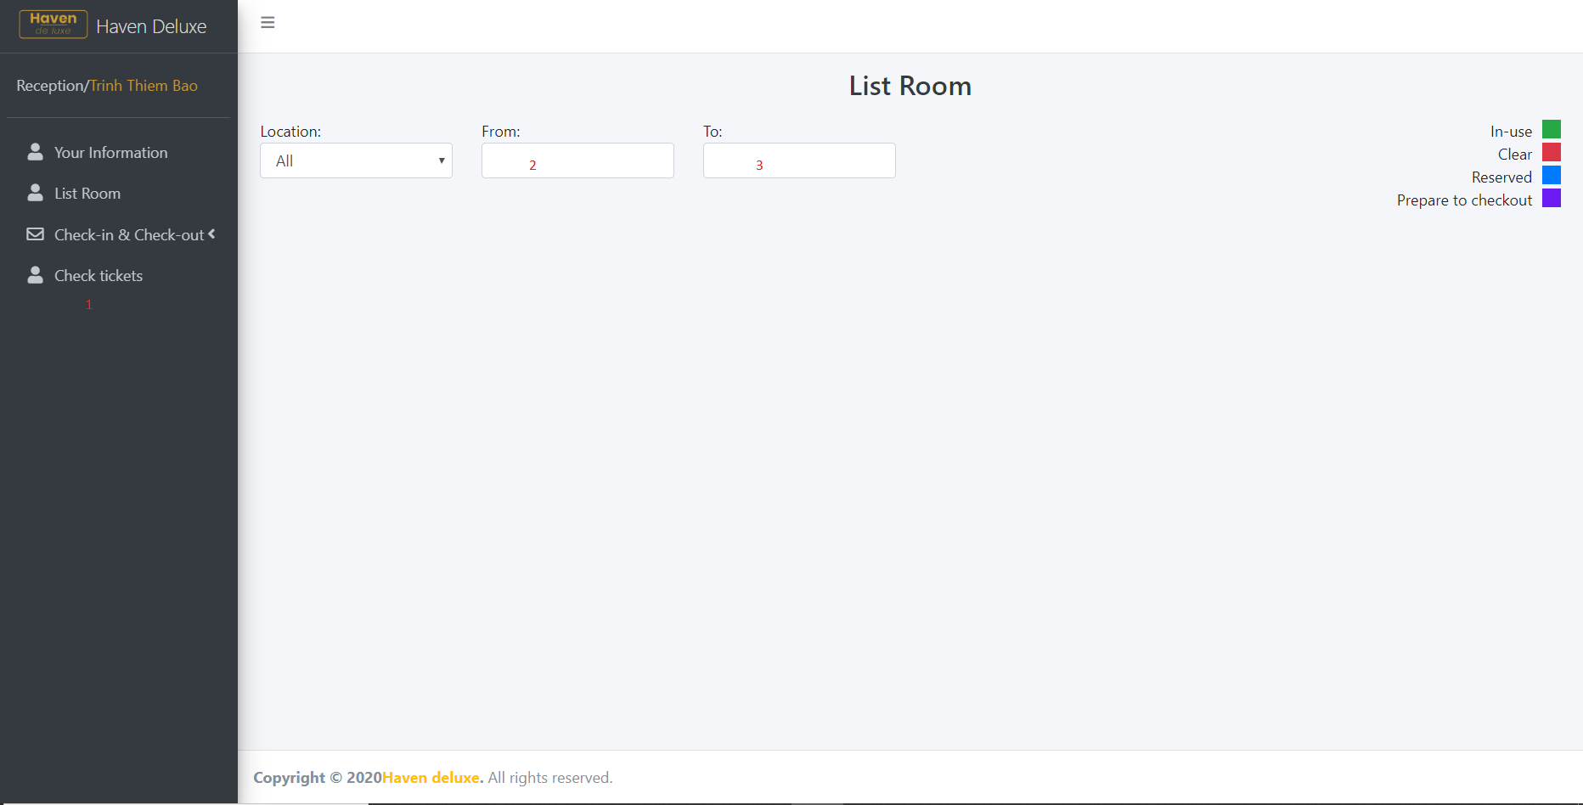

|  |  |  |  |  |  |
| --- | --- | --- | --- | --- | --- |
| No | Name | Type | Event | Description | Status |
| 1 | Nav bar | Hyperlink | Click | Choose & click to go to sub pages | Enable |
| 2 | Date From | Date Time | Click | Choose the date to find the room | Enable |
| 3 | Date To | Date Time | Click | Choose the date to find the room | Enable |

1. **Checkin-Checkout Page :**

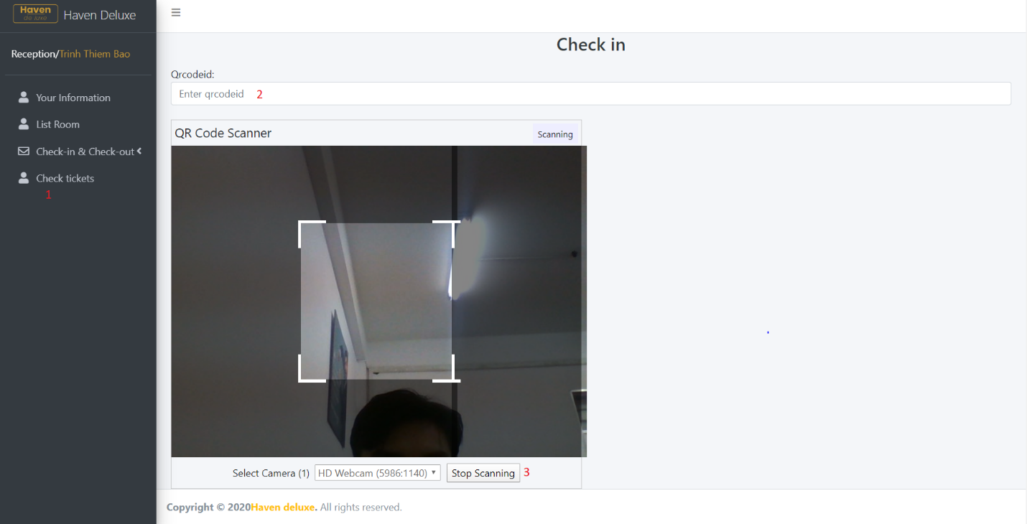

|  |  |  |  |  |  |
| --- | --- | --- | --- | --- | --- |
| No | Name | Type | Event | Description | Status |
| 1 | Nav bar | Hyperlink | Click | Choose & click to go to sub pages | Enable |
| 2 | Qr Code | TextBox | Focus | Enter QrCodeId | Enable |
| 3 | Scanning | Button | Click | Click Scanning for start or Stop Scan | Enable |

1. **Check Tickets Page :**

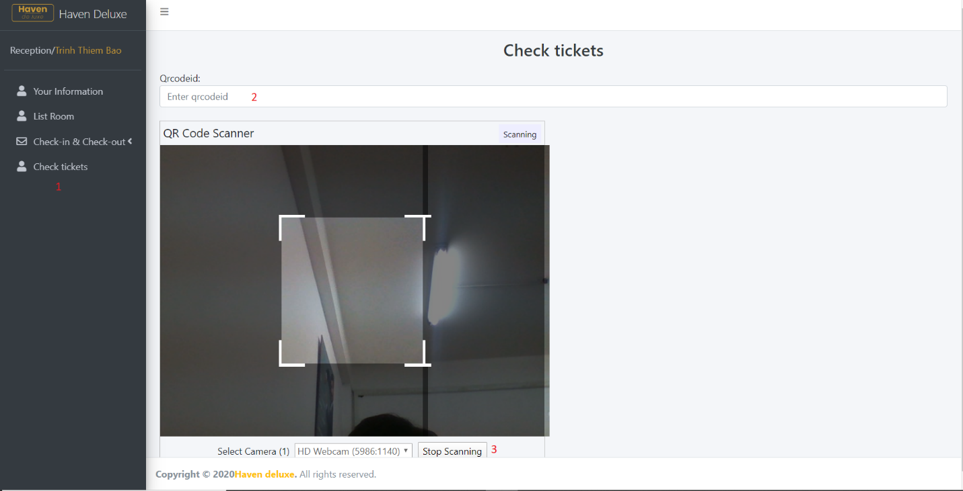

|  |  |  |  |  |  |
| --- | --- | --- | --- | --- | --- |
| No | Name | Type | Event | Description | Status |
| 1 | Nav bar | Hyperlink | Click | Choose & click to go to sub pages | Enable |
| 2 | Qr Code | TextBox | Focus | Enter QrCodeId | Enable |
| 3 | Scanning | Button | Click | Click Scanning for start or Stop Scan | Enable |

|  |  |  |  |  |  |  |
| --- | --- | --- | --- | --- | --- | --- |
| **Project Ref.No: 1** | **Project Title:** | **Activity Plan Prepared By:** | **Date of Preparation of Activity Plan** | | | |
| **Resort Management** |
| **Sr. No.** | **Task** | **Actual Start Date** | **Actual Days** | **Team Mate Names** | **Status** |
| 1 | Database Structure | Mr. Bao | 27/07/2020 | 2 | Thai | Completed |
| 2 | Database Design Diagram | 28/07/2020 | 1 | Thai | Completed |
| 3 | GUI Design Front End | 01/08/2020 | 3 | Thai | Completed |
| 4 | Design Back End | 04/08/2020 | 3 | Thai | Completed |
| 5 | Task sheet review | 05/08/2020 | 1 | Thai | Completed |
| **User Pages** | | | 17/07/2020 | 7 |  |  |
| 1 | Home page | Ms. Tien | Ly Thi Thuy Tien | Completed |
| 2 | Booking page | Ms. Tien |
| 3 | Location page | Ms. Tien |
| 4 | Confirm page | Ms. Tien |
| 5 | Login page | Ms. Tien |
| 6 | Sign up page | Ms. Tien |
| 7 | Forgot pass page | Ms. Tien |
| **Customer Pages** | | |  |
| 1 | Home page | Mr. Bao | Trinh Thiem Bao |
| 2 | Menu Fnd page | Mr. Bao |
| 3 | Entertainment page | Mr. Bao |
| 4 | Information page | Mr. Bao |
| 5 | Ticket page | Mr. Bao |
| 6 | Bill page | Mr. Bao |
| 7 | Feedback page | Mr. Bao |
| 8 | Cart page | Mr. Bao |
| **Admin Pages** | | |
| 1 | Login page | Mr. Bao |
| 2 | Home page | Mr. Bao |
| 3 | QrCode page | Ms.Tien |  |
| 4 | Customer page | Mr. Thai |  |
| 5 | Room page | Mr. Thai |
| 6 | Location page | Mr. Thai |
| 7 | Receipt page | Mr. Thai |  |  | Nguyen Quoc Thai | Completed |
| 8 | Service page | Mr. Thai |
| 9 | Convenient page | Mr. Thai |
| 10 | Employee page | Mr. Thai |
| 11 | Feedback page | Mr. Thai |
| **Employee Pages** | | |  |
| 1 | Home page | Mr. Bao | Trinh Thiem Bao |
| 2 | Information page | Mr. Bao | Trinh Thiem Bao |
| 3 | Room page | Mr. Thai | Nguyen Quoc Thai |
| 4 | Checkin-CheckOut | Ms. Tien | Ly Thi Thuy Tien |
| 5 | Check Tickets | Ms. Tien | Ly Thi Thuy Tien |

|  |  |
| --- | --- |
| **Date: 05/08/2020** | |
| Signature of Instructor:  **Mr. Tran Phuoc Sinh** | Signature of Team Leader:  **Trinh Thiem Bao** |